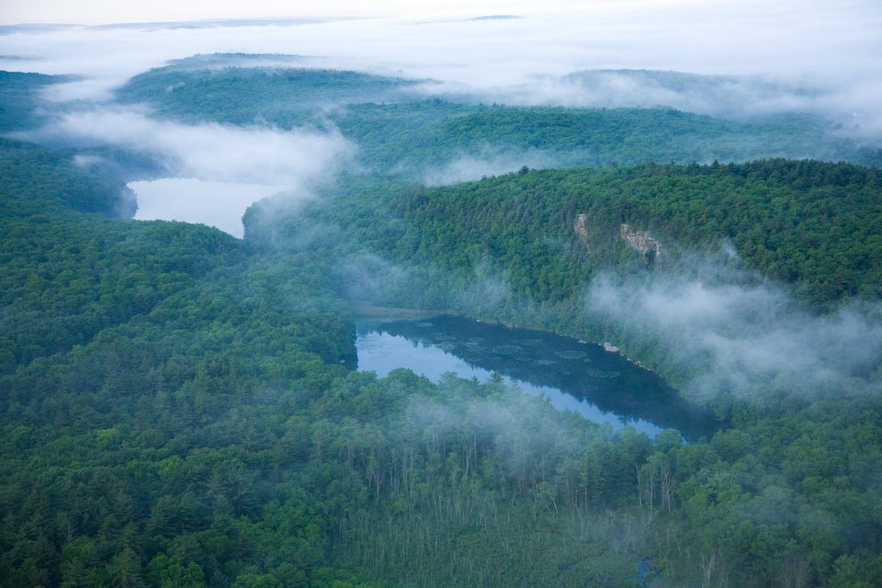

**NATIONAL HERITAGE CORRIDOR**

**A special place**

• 35 towns and 1,100 square miles of

irreplaceable historic and natural

resources

• 77% forests and farm lands

• Third largest watershed draining into

Long Island Sound

• An unexpectedly ancient and authentic

region

• The last stretch of dark night sky in the

coastal sprawl between Boston and

Washington, D.C.

**A dynamic organization**

• Offering a variety of innovative programs

and events designed to connect people to

The Last Green Valley and its resources.

• Registered as a nonprofit 501(c)(3)

organization since 1995.

• Proven long term success in programs and

partnerships.

**“We all live downstream.”**

**Eric Thomas**

**Watershed Manager**

**Connecticut Department of Energy**

**and Environmental Protection**

**CARE FOR IT, ENJOY IT, PASS IT ON!**

The Last Green Valley Volunteer Water Quality

Monitoring Program is a partnership between

TLGV, the Eastern Connecticut Conservation District

and The Connecticut Audubon Society Grassland

Bird Conservation Center in Pomfret.

Funding support for this and other TLGV programs

has been provided by Connecticut Light and Power.

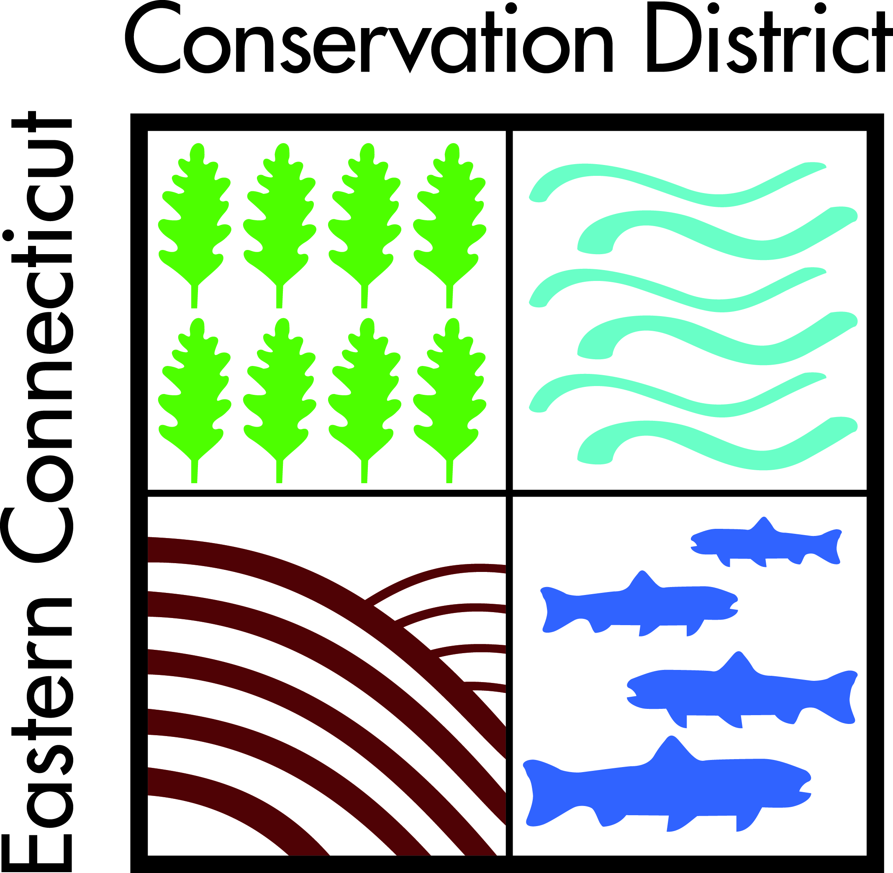 For more information, call or email:

**Jean Pillo, Coordinator**

**TLGV Water Quality**

**Monitoring Program**

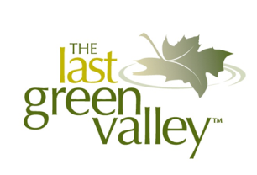 860 928-4948 x 605

Jean.Pillo@ConserveCT.org

**The Last Green Valley**

P.O. Box 29

203B Main Street

 Danielson, CT 06239-0029

860-774-3300

mail@tlgv.org



thelastgreenvalley.org

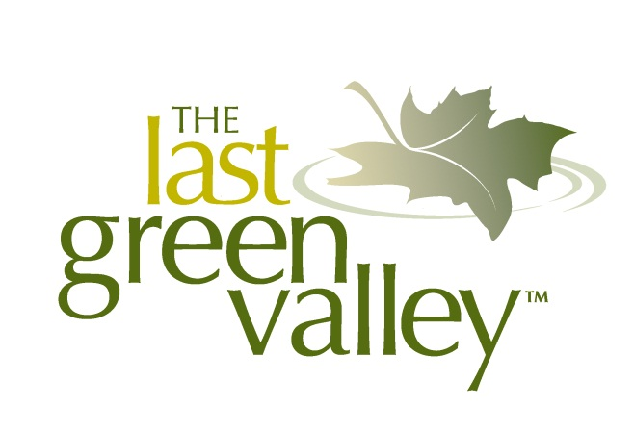

**NATIONAL HERITAGE CORRIDOR**

**How Clean is the Water in**

**The Last Green Valley?**

**You Can Help Us Find Out!**

**Join TLGV’s Volunteer**

**Water Quality**

**Monitoring Program.**

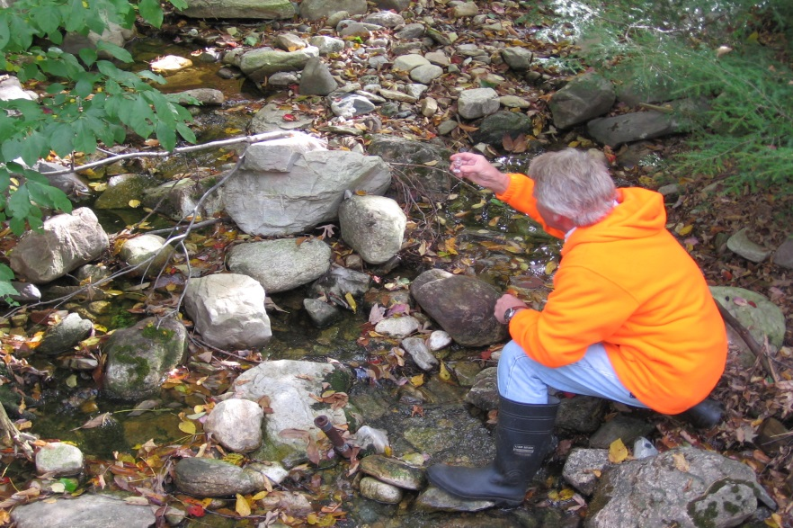

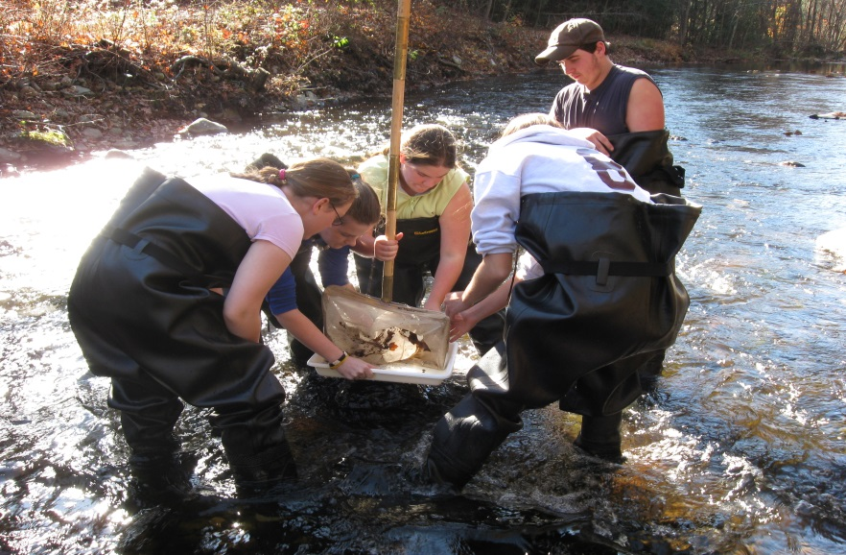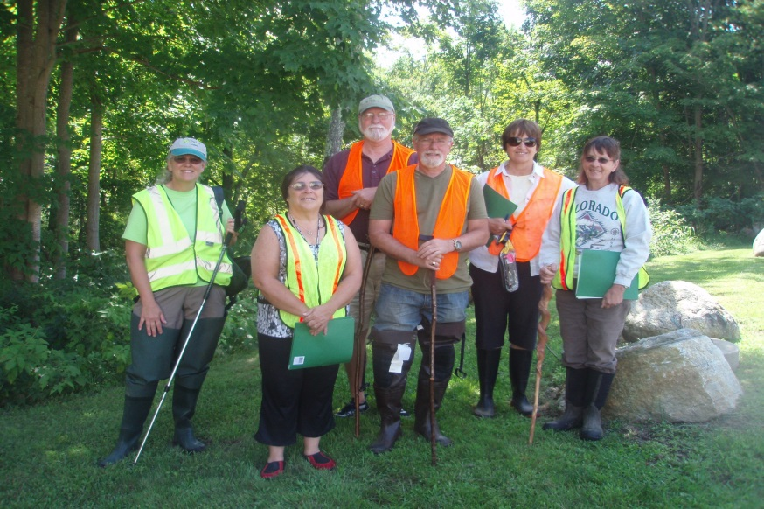

**MANY WAYS TO HELP**

○ **Stream Walk**

**Just as the name implies, volunteers**

**observe and record information collected**

**walking in and along streams during the**

**summer. Stream walkers document healthy**

**conditions as well as problems such as**

**erosion and illegal discharges.**

**○ Bacteria Monitoring**

***E. Coli* is a common bacteria found in the**

**gut of all warm blooded animals, but its**

**presence in water indicates contamination by**

**fecal material. Volunteers collect water**

**samples during the summer to look for**

**bacteria. If pollution is found, the data can**

**be used to help track down the source.**

**○ Water Chemistry Monitoring**

 **A “Troll” is a sophisticated probe that**

**volunteers can use to measure water**

**characteristics such as dissolved oxygen**

**levels, pH, temperature, turbidity, and**

**conductivity. Over time, both short and long-**

**term water quality problems can be detected.**

**WHY VOLUNTEER?**

With hundreds of miles of rivers and streams and more

than 80 lakes and ponds in The Last Green Valley, it’s

impossible for state agencies to monitor water quality

in every location. And as agency budgets shrink, so does

their ability to adequately assess our water bodies.

As a result, TLGV volunteers are needed more than

ever to help fill important data gaps, and TLGV

volunteers are often the first people to detect problems

in the field. The information collected can be used to

set priorities and find solutions that will lead to

improved water quality.

TLGV can match your interests and availability with

one of our monitoring programs. Whether you’re able

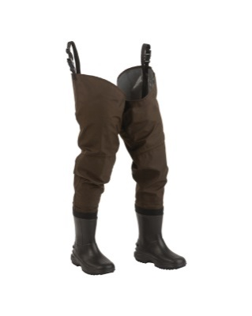 to monitor once a week or once a year,

our program can accommodate your

schedule. Whether you’d like to wade

in streams, catch bugs in nets, collect

water samples in jars, or probe a lake

to take its temperature, you will make

a difference and the data you collect

will have a long-lasting impact.

TLGV will provide training, equipment, and a sincere

“thank you” for your efforts.

**Become a water quality monitoring**

**volunteer today!**

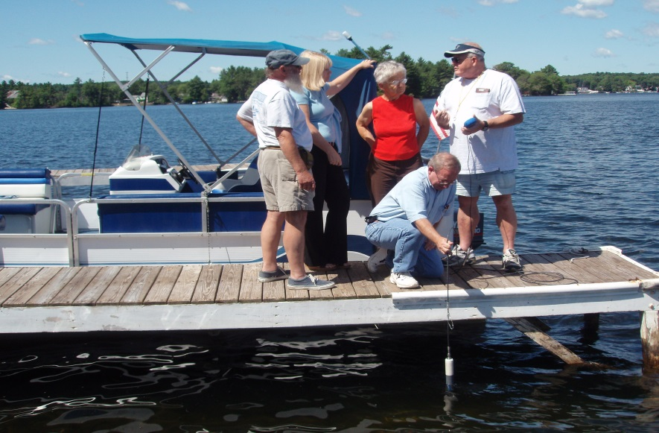

**MORE WAYS TO HELP**

**C:\Users\ccutler\AppData\Local\Microsoft\Windows\Temporary Internet Files\Content.IE5\B4ZLHT95\MC900350495[1].wmf**

**○ River Bioassessment for Volunteers**

**RBV is a complicated name for a simple**

**method of collecting bugs that live along**

**stream bottoms. Like trout, some bugs need**

**cold, oxygen-rich water to survive; other fish**

**and bugs can survive is some pretty dreadful**

**conditions. By netting and sorting bugs from**

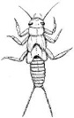 **a stream, volunteers can learn a lot about**

**water quality.**

**○ Secchi Disk Monitoring**

**A secchi disk is a black and white disk that**

**volunteers lower into lakes and ponds to**

**measure water clarity.**

**○ Water Temperature Monitoring**

**TLGV volunteers place “Hobos” in streams**

**to measure long-term trends in water**

** temperature.**

**○ Nutrient Monitoring**

**Nutrients like phosphates and nitrates are**

**necessary for plant growth, but too many**

**nutrients can cause uncontrolled blooms in**

**water bodies. When aquatic plants and algae**

**die, the decay process can use up all the**

**oxygen in the water, leading to fish kills.**

**Volunteers use a number of tools to measure**

**nutrient levels in our water bodies.**