Southern New England Heritage Forest (SNEHF)
Regional Conservation Partnership Program (RCPP)
Healthy Forest Reserve Program (HFRP) Application

Funding Announcement - May 7, 2018
First Round Deadline – 4 pm on July 20, 2018

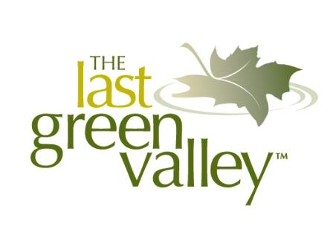
Lead Partners:

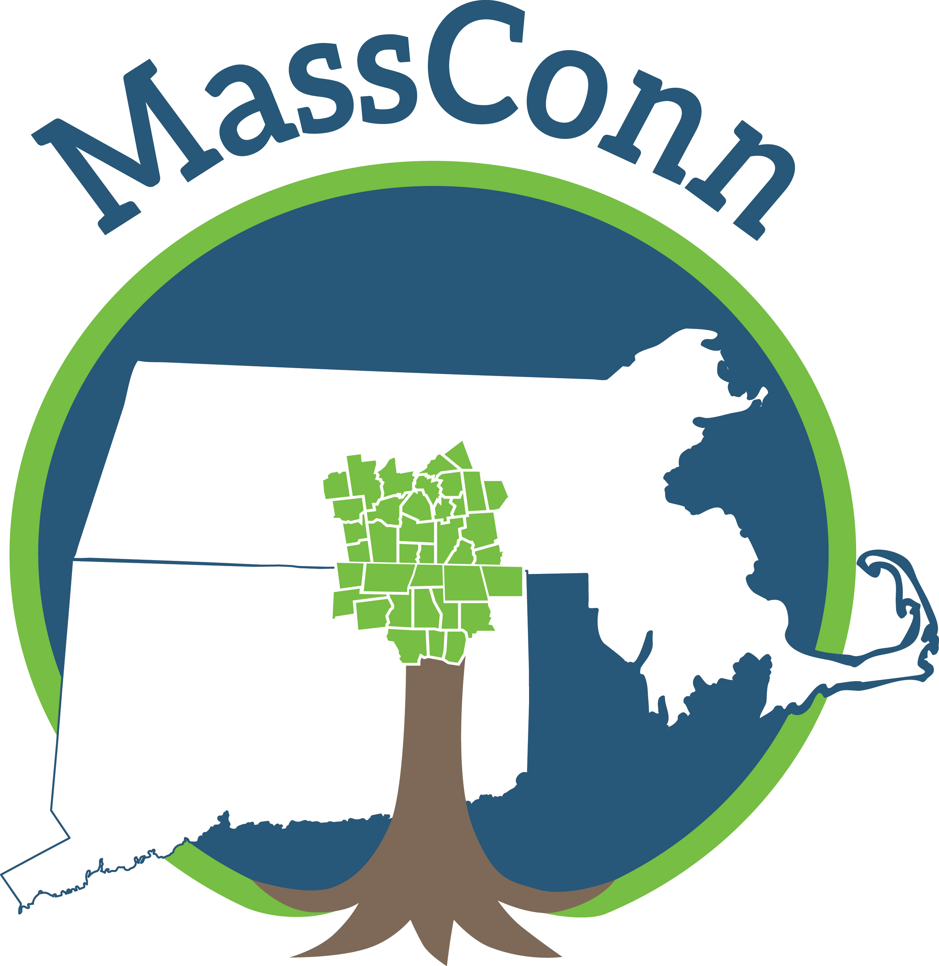

For Connecticut Projects For Massachusetts Projects For Rhode Island Projects
The Last Green Valley MassConn Sustainable Northern RI Conservation
Forest Partnership District
Bill Reid Ed Hood Kate Sayles
Bill@tlgv.org ehood@opacumlt.org ksayles.nricd@gmail.com
860-774-3300 508-347-9144 (leave a voice- 401-934-0840
mail with your contact info)

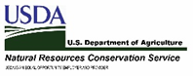

This project is funded in part by a Regional Conservation Partnership Program Grant #68-1106-17-058 from the Natural Resources Conservation Service, U.S. Department of Agriculture.

Supporting Partners: MA Executive Office of Energy and Environmental Affairs, Providence Water, Yale School of Forestry & Environmental Studies, CT Department of Energy and Environmental Protection, Hull Forest Products, Thames River Basin Partnership, New England Forestry Foundation, Eastern CT Conservation District, Norcross Wildlife Foundation, RI Division of Forest Management, RI Woodland Partnership, Harvard Forest, Yale Sustaining Family Forests Institute, Audubon Connecticut, Mass Audubon, and Audubon RI.

Dear Landowner:

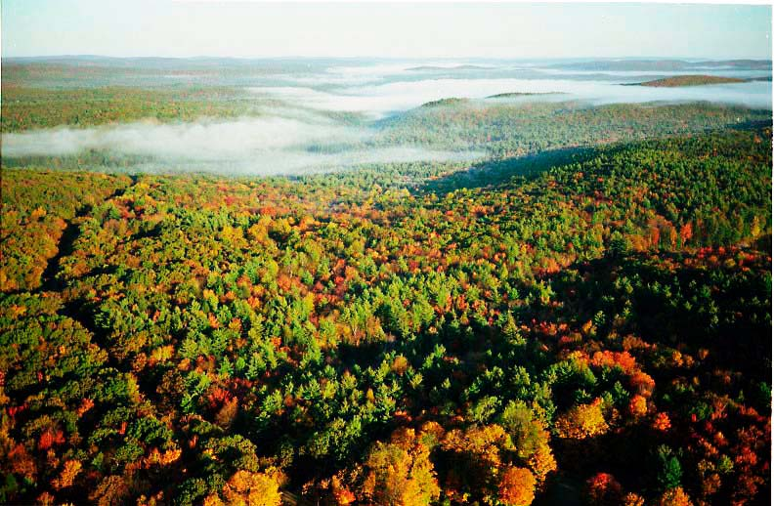
Thank you for considering the Healthy Forest Reserve Program (HFRP) as an opportunity for conserving and protecting your woodlands. As a landowner in the Southern New England Heritage Forest (SNEHF), your woods are part of a 1.49 million-acre unfragmented forest corridor stretching along the Connecticut and Rhode Island border to the Quabbin Reservoir in Massachusetts. Bounded by more heavily urbanized areas, with more than one million nearby residents, the SNEHF has an astonishing 76% forest cover and offers one of the last viable wildlife corridors from southern to northern New England. The SNEHF is a green oasis and the last undeveloped region in the coastal sprawl from Boston to Washington, D.C.

Because the SNEHF is so significant, a conservation partnership was formed to bring additional funding to the region through the USDA Natural Resources Conservation Service (NRCS). Known as a Regional Conservation Partnership Program (RCPP), this innovative project and dedicated funding pool will help private landowners protect their woodlands in perpetuity.

SNEHF RCPP Landowner Benefits
Landowners will be able to permanently protect their woodlands by granting a conservation easement to NRCS. NRCS will pay the landowner 75% of the fair market value of the enrolled land in order to promote the recovery of endangered and threatened species, improve plant and animal biodiversity and enhance carbon sequestration. The specific focus of this RCPP is on important bird species and their habitats.

NRCS will pay for transaction costs including a title search, boundary survey, hazardous materials search and appraisal. NRCS will draft a restoration plan for the property that focuses on improving habitat for a specific bird species and will provide 75% of the funds for the first round of any restoration work that is required.

SNEHF RCPP Landowner Responsibilities
The landowner must be prepared for a 2-3-year process and be willing to cooperate with NRCS by providing information, allowing agency site visits, and assenting to the development of a site-specific restoration plan for a specific bird species. Once finalized, the landowner must maintain the property in accordance with the restoration plan.

Application Instructions
1) Please consult with the lead partner for the state in which your woodlands (or the majority of your woodlands) are located. The partner can provide technical assistance and help you put together an application package.

2) Review the following resources to be sure you understand the parameters of the SNEHF RCPP HFRP program:

Healthy Forest Reserve Program
https://www.nrcs.usda.gov/wps/portal/nrcs/main/national/programs/easements/forests/

Healthy Forest Reserve Program Sample Conservation Easement Deed
https://www.nrcs.usda.gov/Internet/FSE_DOCUMENTS/nrcs143_006835.pdf

NRCS - A Guide to the Southern New England Heritage Forest Regional Conservation Partnership Program Healthy Forests Reserve Program: http://thelastgreenvalley.org/wp-content/uploads/2018/05/Guide-to-the-SNEHF-RCPP-HFRP-rev-5-2-2018.pdf

SNEHF Mapper: http://harvard-cga.maps.arcgis.com/apps/webappviewer/index.html?id=befdd12b4a2a4411a5aa25c4690a6316

3) File paperwork with the USDA Farm Services Agency (FSA) in order to receive farm and tract numbers and confirm eligibility. If you have not previously filed with FSA, we recommend that you do so by July 1 to ensure eligibility is resolved before the July 20 application deadline for this RCPP. FSA requires you to fill out a number of forms that are not listed here. You will need to bring evidence of land ownership and a map of property boundaries to the county FSA office.

4) Collect the required documents and complete the application forms listed below. Your lead partner can provide assistance, but it is the applicant’s responsibility to ensure a complete application is submitted prior to the deadline. Late or incomplete applications will not be considered. The original application should be submitted to the NRCS office for the state where the parcel(s) are located, with a copy to the lead partner in your state. Digital submissions, with printed copies to follow, are permissible. The deadline for submission is 4 pm on July 20, 2018.

Document Checklist:
1. SNEHF RCPP HFRP Application Form
2. NRCS Form NRCS-CPA 1200, Conservation Program Application
3. Assessor’s Map showing parcel and Map, Block, Lot Numbers and
Acres and Confirmation of Tax Status
4. Locus Map, GIS Map, or Screen Shot of Online map tool showing
parcel’s location in relation to Eligibility and Ranking Criteria
5. Copy of Forest Management Plan or Landowner Statement of Intent
6. Copy of deed and any recorded encumbrances
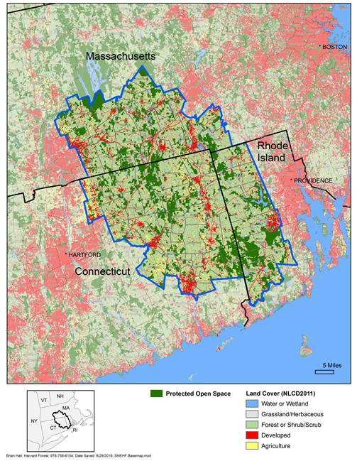

The Southern New England Heritage Forest (SNEHF) was recognized as a priority landscape by the New England Governors’ Conference Commission on Land Conservation in 2010, a designation that has spurred conservation efforts and led to partnerships and projects such as this RCPP to accelerate the pace of conservation in the region.

Southern New England Heritage Forest (SNEHF)
Regional Conservation Partnership Program (RCPP)
Healthy Forest Reserve Program (HFRP) Application Form

1. Applicant and Parcel Information

Landowner Name(s)

Landowner Address

Landowner Phone

Landowner Email

Parcel Location (Street, Town, County, State)

Assessor’s Map-Block-Lot Number
Assessor’s Number of Acres

FSA Farm & Tract Number

2. SNEHF RCPP HFRP Eligibility Criteria
If the answer to any of the following criteria is "no," the application is ineligible for program enrollment.
Does the applicant qualify as an eligible individual or entity? Yes No
Is the parcel privately owned? Yes No
Did the landowner provide a copy of the deed or other documentation showing
that the landowner has title to the land? Yes No
Note: Easement applicants must be able to convey clear title to the land. If the land is mortgaged or subject to other recorded encumbrances, then the associated encumbrances need to be paid off or subordinated to the NRCS easement.
Is the parcel within the Southern New England Heritage Forest (see
SNEHF Mapper)? Yes No
Does the parcel contain habitat capable of supporting federal or state-listed
species, as determined by land capable of supporting at least one of the six
surrogate species identified on the parcel in the SNEHF Mapper? Yes No
3. Landowner Management Options for Long-Term Wildlife Habitat Management

The SNEHF RCPP will prioritize Healthy Forest Reserve Program funding for parcels that contain habitat for federally-listed and state-listed species. There is a relatively small number of migratory bird species whose habitat needs mirror those of many other state-listed species including state-listed species of greatest conservation need and for more than one state. These bird species are called surrogate species. Below is a list of 6 surrogate species, their habitat needs, and a general description of the management activity that would sustain the habitat for the species in perpetuity. In the case of the prairie warbler, more open and cleared land would need to be restocked with trees naturally, and once grown, would be managed as more mature forested habitat and not need to be maintained in an open state.

Please respond with a YES or NO in the box to the right for each category of management that you would be willing to maintain over the course of your ownership of the land.

Surrogate Species | Habitat Type | Management Treatments | Habitat Visual Description | Willing to Manage Your Land for this  Species? Yes/No
Louisiana Waterthrush & Wood Thrush | Mature Upland and Riparian Hardwood Forest | - Maintain forest within blocks greater than 250 acres with a dense understory of saplings and shrubs.  - A suggested buffer of 100 m (328 feet) on either side of stream should be protected around the species’ core riparian habitat for Louisiana Waterthrush.  - Create gaps in the forest canopy so that young saplings and shrubs can grow to provide cover. Single-tree and small group selection silviculture is often compatible with providing high-quality wood thrush nesting habitat. Patches of young, even- aged forest can provide post-breeding foraging and cover habitat.  - Manage forests to create or maintain a dense understory of shrubs and saplings including opportunities for nest sites (fallen streamside logs and stumps) within its breeding range.  - Maintain understory by limiting over-browsing by white-tailed deer through herd culling or other methods.  - Stream quality is important as foraging habitat for Louisiana Waterthrushes. Good water quality and relatively high amounts of riffle and accompanying exposed rock and stream edge provide not only food, but foraging habitat for Louisiana Waterthrushes.  - Minimize edges and create corridors between smaller forest patches to increase habitat quality. | 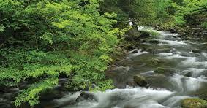  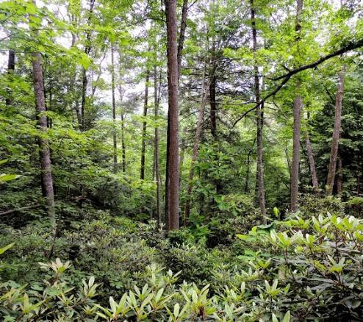

Blackburnian Warbler | Mature Mixed Forest | - Maintain or develop patches of dominant and co-dominant (canopy position) conifers within hardwood-dominated areas.  - Softwood inclusions of hemlock or spruce are key elements within northern hardwood systems.  - Maintain ecologically mature and over mature coniferous forest.  - Light selective harvesting using uneven-aged silvicultural treatments may be compatible with maintaining desirable nesting habitat conditions.  - Avoid fragmenting large contiguous forest tracts.  - Attempt to manage for forest shapes that create the least amount of edge. Circular plots are the best at maximizing forest interior, whereas square or rectangular plots are better than long, narrow strips. Circular forest plots offer less access to the interior for predators and nest parasites while maximizing habitat for area-sensitive species. Research shows that area- sensitive species tend to use forested areas that are at least 330 feet (100 meters) from an edge.  - Minimize isolation of forest patches by promoting reforestation of gaps between disconnected forest tracts. Forest birds generally have higher reproductive success in forest that is either connected to or in-close-proximity to other forest patches. This also facilitates dispersal and territory establishment. | 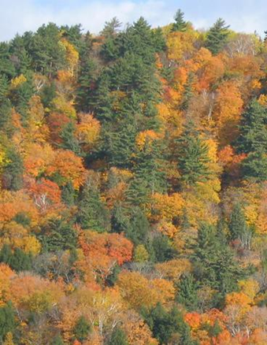

Northern Waterthrush and Red-shouldered Hawk | Forested Wetland | - Maintain forest and shrub/sapling cover in wetland areas.  - Use single-tree selection to maintain 65-70% crown closure within 75 feet of wetland edge.  - Small-group selection (up to ¼ acre openings) beyond 75 feet of wetland edge may be appropriate.  - Minimize disruption to hydrology of wetland habitat.  - Preserve large tracts of deciduous forest (over 25 acres (in mid-to-late successional states, particularly low, wet woods, streams, lakes or marshes.  - Avoid cutting riparian forests.  - Avoid constructing roads in riparian corridors.  - Encourage the reforestation of blocks of lowland areas with hardwoods.  - Minimize disturbance by hikers, hunters, horseback rider and off-road vehicles during the breeding season from mid-March to the end of June. | 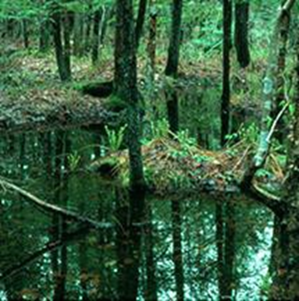

Prairie Warbler | Young Forest & Shrubland | - Maintain adequate patch size: Shrub habitats between 5-25 acres will provide habitat to a number of at-risk species; in general, larger is better. However, smaller, isolated patches less than 5 acres can also provide habitat to some at-risk species.  - Control woody vegetation for as long as willing. The mechanism and frequency of management you employ will depend on the current structure and species make-up of the area you are interested in managing; tree species require more management compared to shrubs. On average, shrub habitats need to be managed every 5-10 years, sometimes less frequently.  - If you have existing shrub habitat without trees (i.e., areas with shrubs interspersed with openings of grasses and forbs), management may be required only every 2-4 years (sometimes less frequently) to prevent the openings from reverting to forest. | 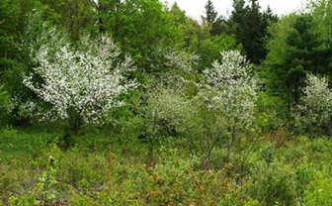

Management Option Sources: Derived from LIS RCPP Documentation: Louisiana Waterthrush; Adapted from “Louisiana Waterthrush, Minnesota Conservation Summary,” Audubon Minnesota (Spring 2014); Wood Thrush: Adapted from “A Landowners Guide to Improving Habitat for Forest Thrushes,” Cornell Lab of Ornithology (2003); Blackburnian Warbler: Adapted from “Focus Species Forestry,” Rob Bryan (2004) and “A Land Manager’s Guide to Improving Habitat for Scarlet Tanagers and other Forest-interior Birds,” Cornell Lab of Ornithology (1999); Northern Waterthrush: Adapted from “Focus Species Forestry,” Rob Bryan (2004); Red-shouldered Hawk: Adapted from Crocoll 1994, James 1984 and NYSDEC 2008; Prairie Warbler: http://ny.audubon.org/conservation/managing-habitat-shrubland-birds-0.

4. Applicant Signature
I hereby certify that the information in this application is true and correct to the best of my knowledge.
_______________________________________ ________________
Applicant Signature Date

SNEHF RCPP HFRP Scoring/Ranking Criteria
Scoring and ranking priorities vary by state, and final numbers will be calculated by the lead partners in consultation with NRCS in each state. The scoring/ranking criteria are presented here for your information but do not have to be completed prior to submitting an application. Choose the appropriate scoring/ranking worksheet based upon the property’s location. For parcels that cross state lines, consult the partners for assistance.
The scoring/ranking criteria for Massachusetts, Connecticut and Rhode Island follow:
Massachusetts Healthy Forest Reserve Program (HFRP) Scoring/Ranking Worksheet
Southern New England Heritage Forest (SNEHF)
Regional Conservation Partnership Program (RCPP)

Criteria | Maximum Points | Points
1. The application package contains a long-term (10+ years) forest management plan completed by a licensed professional forester and a landowner statement of intent signifying their willingness to have land managed as habitat in perpetuity.  SCALE: Active Long-term forest management plan attached = 100 points; landowner statement of intent attached = 30 points, both = 130 points. Zero points if not attached. | 130
2. Enrollment in state current use programs.  SCALE: If the parcel is currently enrolled in either MA Chapter 61 or 61B, score 70 points. If not, score 0 points. | 70
3. The number of acres of forestland.  SCALE: 1 point for each acre of forested land to be treated with an HFRP easement. Maximum points = 100. See web map Land Cover layer for this information; this score will be also calculated by SNEHF staff. | 100
4. The number of acres in area defined as being within the SNEHF Conservation Priority Focus Areas.  SCALE: 4.6 points for each acre of land in the SNEHF Conservation Priority Focus Areas, as identified on the SNEHF web map SNEHF Conservation Priority Focus Area layer. This score will be calculated by SNEHF staff. Maximum points = 460. | 460
5. The number of acres within Blocks of Natural Land of the following acreages; multiply the parcel's acres to be protected by the factor associated with the Land Block category.  SCALE: If more than one Block type is present in the project parcel, multiply the acres within each Block type by the Block factor and add the total number, up to 100 points. Maximum points = 100.  Natural Land Block Sizes:  1 – 250 acres: parcel acres x .2  251 – 500 acres: parcel acres x .3  501 – 750 acres: parcel acres x .4  751 – 1000 acres: parcel acres x .5  1001 -2500 acres: parcel acres x .6  2501 - 5000 acres: parcel acres x .7  5001 – 7500 acres: parcel acres x .8  7501 – 15000 acres: parcel acres x .9  15001 – 55897 acres: parcel acres x 1.0  See web map Blocks of Natural Land layer for more information; this score will be calculated by SNEHF staff. | 100
6. The proximity of the parcel to other protected forest land. Select one single score scaling that gives the parcel the highest score--do not add them if multiple criteria apply to the parcel.  SCALE:  No protected forest land within 1 mile of parcel: 0 points  1 to 500 acres of protected forest land within 1 mile of parcel: 5 points  >500 acres of protected forest land within 1 mile of parcel: 10 points  1 to 500 acres of protected forest land within 1/4 mile of parcel: 25 points  >500 acres of protected forest land within 1 /4 mile of parcel: 50 points  1 to 500 acres of protected forest land contiguous with parcel: 75 points  501 or more acres of protected forest land contiguous with parcel: 100 points  NOTE: “Protected forest land” consists of land identified as, 1) being forested or forested wetland on the Land Cover layer, and 2) is shown to be Protected Open Space on the SNEHF Mapper or which can otherwise be documented to be protected open space. This score will be calculated by SNEHF staff. Maximum points = 100. | 100
7. Parcel is adjacent/contiguous to another parcel under similar consideration for SNEHF RCPP or Long Island Sound Watershed RCPP Healthy Forest Reserve Program.  SCALE: If adjacent/contiguous to another parcel under consideration, score 40 points. Zero points if not adjacent/contiguous to another parcel under consideration. This will be calculated by SNEHF staff. | 40
Total Points | 1000

Connecticut Healthy Forest Reserve Program (HFRP) Scoring/Ranking Worksheet
Southern New England Heritage Forest (SNEHF)
Regional Conservation Partnership Program (RCPP)

Criteria | Maximum Points | Points
1. The application package contains a long-term (10+ years) forest management plan completed by a licensed professional forester and a landowner statement of intent signifying their willingness to have land managed as habitat in perpetuity.  SCALE: Active Long-term forest management plan attached = 100 points, landowner statement of intent attached = 30 points, both = 130 points. Zero points if not attached. | 130
2. Enrollment in state current use programs.  SCALE: If the parcel is currently enrolled in CT PA 490, score 70 points. If not, score 0 points. | 70
3. The number of acres of forestland.  SCALE: 1 point for each acre of forested land to be treated with an HFRP easement. Maximum points = 100. See web map Land Cover layer for this information; this score will be also calculated by SNEHF staff. | 100
4. The number of acres in area defined as being within the SNEHF Conservation Priority Focus Areas.  SCALE: 3 points for each acre of land in the SNEHF Conservation Priority Focus Areas, as identified on the SNEHF web map SNEHF Conservation Priority Focus Area layer. This score will be calculated by SNEHF staff. Maximum points = 300. | 300
5. The number of acres within Blocks of Natural Land of the following acreages; multiply the parcel's acres to be protected by the factor associated with the Land Block category.  SCALE: If more than one Block type is present in the project parcel, multiply the acres within each Block type by the Block factor and add the total number, up to 100 points. Maximum points = 100  Natural Land Block Sizes:  1 – 250 acres: parcel acres x .2  251 – 500 acres: parcel acres x .3  501 – 750 acres: parcel acres x .4  751 – 1000 acres: parcel acres x .5  1001 -2500 acres: parcel acres x .6  2501 - 5000 acres: parcel acres x .7  5001 – 7500 acres: parcel acres x .8  7501 – 15000 acres: parcel acres x .9  15001 – 55897 acres: parcel acres x 1.0  See web map Blocks of Natural Land layer for more information; this score will be calculated by SNEHF staff. | 100
6. The proximity of the parcel to other protected forest land. Select one single score scaling that gives the parcel the highest score--do not add them if multiple criteria apply to the parcel.  SCALE:  No protected forest land within 1 mile of parcel: 0 points  1 to 500 acres of protected forest land within 1 mile of parcel: 5 points  >500 acres of protected forest land within 1 mile of parcel: 10 points  1 to 500 acres of protected forest land within 1/4 mile of parcel: 25 points  >500 acres of protected forest land within 1 /4 mile of parcel: 50 points  1 to 500 acres of protected forest land contiguous with parcel: 75 points  501 or more acres of protected forest land contiguous with parcel: 100 points  NOTE: “Protected forest land” consists of land identified as, 1) being forested or forested wetland on the Land Cover layer, and 2) is shown to be Protected Open Space on the SNEHF Mapper or which can otherwise be documented to be protected open space. This score will be calculated by SNEHF staff. Maximum points = 100. | 100
7. State-specific criteria, 40 points each.  a. Parcel is within an Important Bird Area as determined by Audubon Forest Focal Areas Or Other Critical Bird Habitat data layer in the SNEHF mapper.  b. Parcel is within a public drinking water supply watershed (Class AA or A) as determined using Public Drinking Water Supply Surface Waters layer in the SNEHF mapper.  c. Parcel is within or contiguous to a Natural Diversity Database Area or other critical habitat as determined using the Contains Natural Diversity Database Or Other Critical Habitat data layer in the SNEHF mapper.  d. Index of Ecological Integrity: A portion of the parcel must be within the top 25% of that ecosystem within the state, in order to receive points as determined using the Top 25% Index of Ecological Integrity data layer in the SNEHF mapper.  e. Parcel is adjacent/contiguous to another parcel under similar consideration for SNEHF RCPP or Long Island Sound Watershed RCPP Healthy Forest Reserve Program. To be calculated by SNEHF staff.  SCALE: If any portion of a parcel falls with a criterion, score 40 points for that criterion. If the parcel falls outside of the criterion, score 0 points for that criterion. SNEHF staff will calculate the score. Maximum = 40 points per criterion, 200 points total maximum. | 200
Total Points | 1000

Rhode Island Healthy Forest Reserve Program (HFRP) Scoring/Ranking Worksheet
Southern New England Heritage Forest (SNEHF)
Regional Conservation Partnership Program (RCPP)

Criteria | Maximum Points | Points
1. The application package contains a long-term (10+ years) forest management plan completed by a licensed professional forester and a landowner statement of intent signifying their willingness to have land managed as habitat in perpetuity.  SCALE: Active Long-term forest management plan attached = 100 points, landowner statement of intent attached = 30 points, both = 130 points. Zero points if not attached. | 130
2. Enrollment in state current use programs.  SCALE: If the parcel is currently enrolled in RI FFOS status, score 70 points. If not, score 0 points. | 70
3. The number of acres of forestland.  SCALE: 1 point for each acre of forested land to be treated with an HFRP easement. Maximum points = 100. See web map Land Cover layer for this information; this score will be also calculated by SNEHF staff. | 100
4. The number of acres in area defined as being within the SNEHF Conservation Priority Focus Areas.  SCALE: 1 point for each acre of land in the SNEHF Conservation Priority Focus Areas, as identified on the SNEHF web map SNEHF Conservation Priority Focus Area layer. This score will be calculated by SNEHF staff. Maximum points = 100. | 100
5. The number of acres within the RI Watershed Priority Focus Area.  - Scituate Reservoir Watershed, RI  SCALE: 3 points for each acre of land in the RI Watershed Priority Focus Area as identified on the SNEHF web map RI Watershed Priority Focus Area layer. This score will be calculated by SNEHF staff. Maximum points = 360. | 360
6. The number of acres within Blocks of Natural Land of the following acreages; multiply the parcel's acres to be protected by the factor associated with the Land Block category.  SCALE: If more than one Block type is present in the project parcel, multiply the acres within each Block type by the Block factor and add the total number, up to 100 points. Maximum points = 100.  Natural Land Block Sizes:  1 – 250 acres: parcel acres x .2  251 – 500 acres: parcel acres x .3  501 – 750 acres: parcel acres x .4  751 – 1000 acres: parcel acres x .5  1001 -2500 acres: parcel acres x .6  2501 - 5000 acres: parcel acres x .7  5001 – 7500 acres: parcel acres x .8  7501 – 15000 acres: parcel acres x .9  15001 – 55897 acres: parcel acres x 1.0  See web map Blocks of Natural Land layer for more information; this score will be calculated by SNEHF staff. | 100
7. The proximity of the parcel to other protected forest land. Select one single score scaling that gives the parcel the highest score--do not add them if multiple criteria apply to the parcel.  SCALE:  No protected forest land within 1 mile of parcel: 0 points  1 to 500 acres of protected forest land within 1 mile of parcel: 5 points  >500 acres of protected forest land within 1 mile of parcel: 10 points  1 to 500 acres of protected forest land within 1/4 mile of parcel: 25 points  >500 acres of protected forest land within 1 /4 mile of parcel: 50 points  1 to 500 acres of protected forest land contiguous with parcel: 75 points  501 or more acres of protected forest land contiguous with parcel: 100 points  NOTE: “Protected forest land” consists of land identified as, 1) being forested or forested wetland on the Land Cover layer, and 2) is shown to be Protected Open Space on the SNEHF Mapper or which can otherwise be documented to be protected open space. This score will be calculated by SNEHF staff. Maximum points = 100. | 100
8. Parcel is adjacent/contiguous to another parcel under similar consideration for SNEHF RCPP or Long Island Sound Watershed RCPP Healthy Forest Reserve Program.  SCALE: If adjacent/contiguous to another parcel under consideration, score 40 points. Zero points if not adjacent/contiguous to another parcel under consideration. This will be calculated by SNEHF staff. | 40
Total Points | 1000

