Southern New England Heritage Forest (SNEHF)
Regional Conservation Partnership Program (RCPP)
Environmental Quality Incentives Program (EQIP) Application

Forest Management Plans with Bird Habitat Assessment
Cost-share Assistance Program - Massachusetts
2019

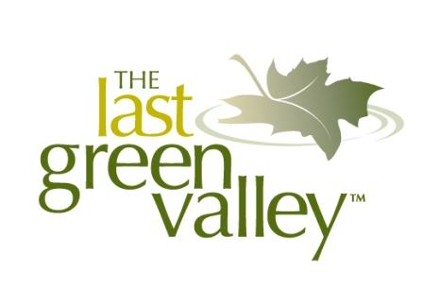
Lead Partners:

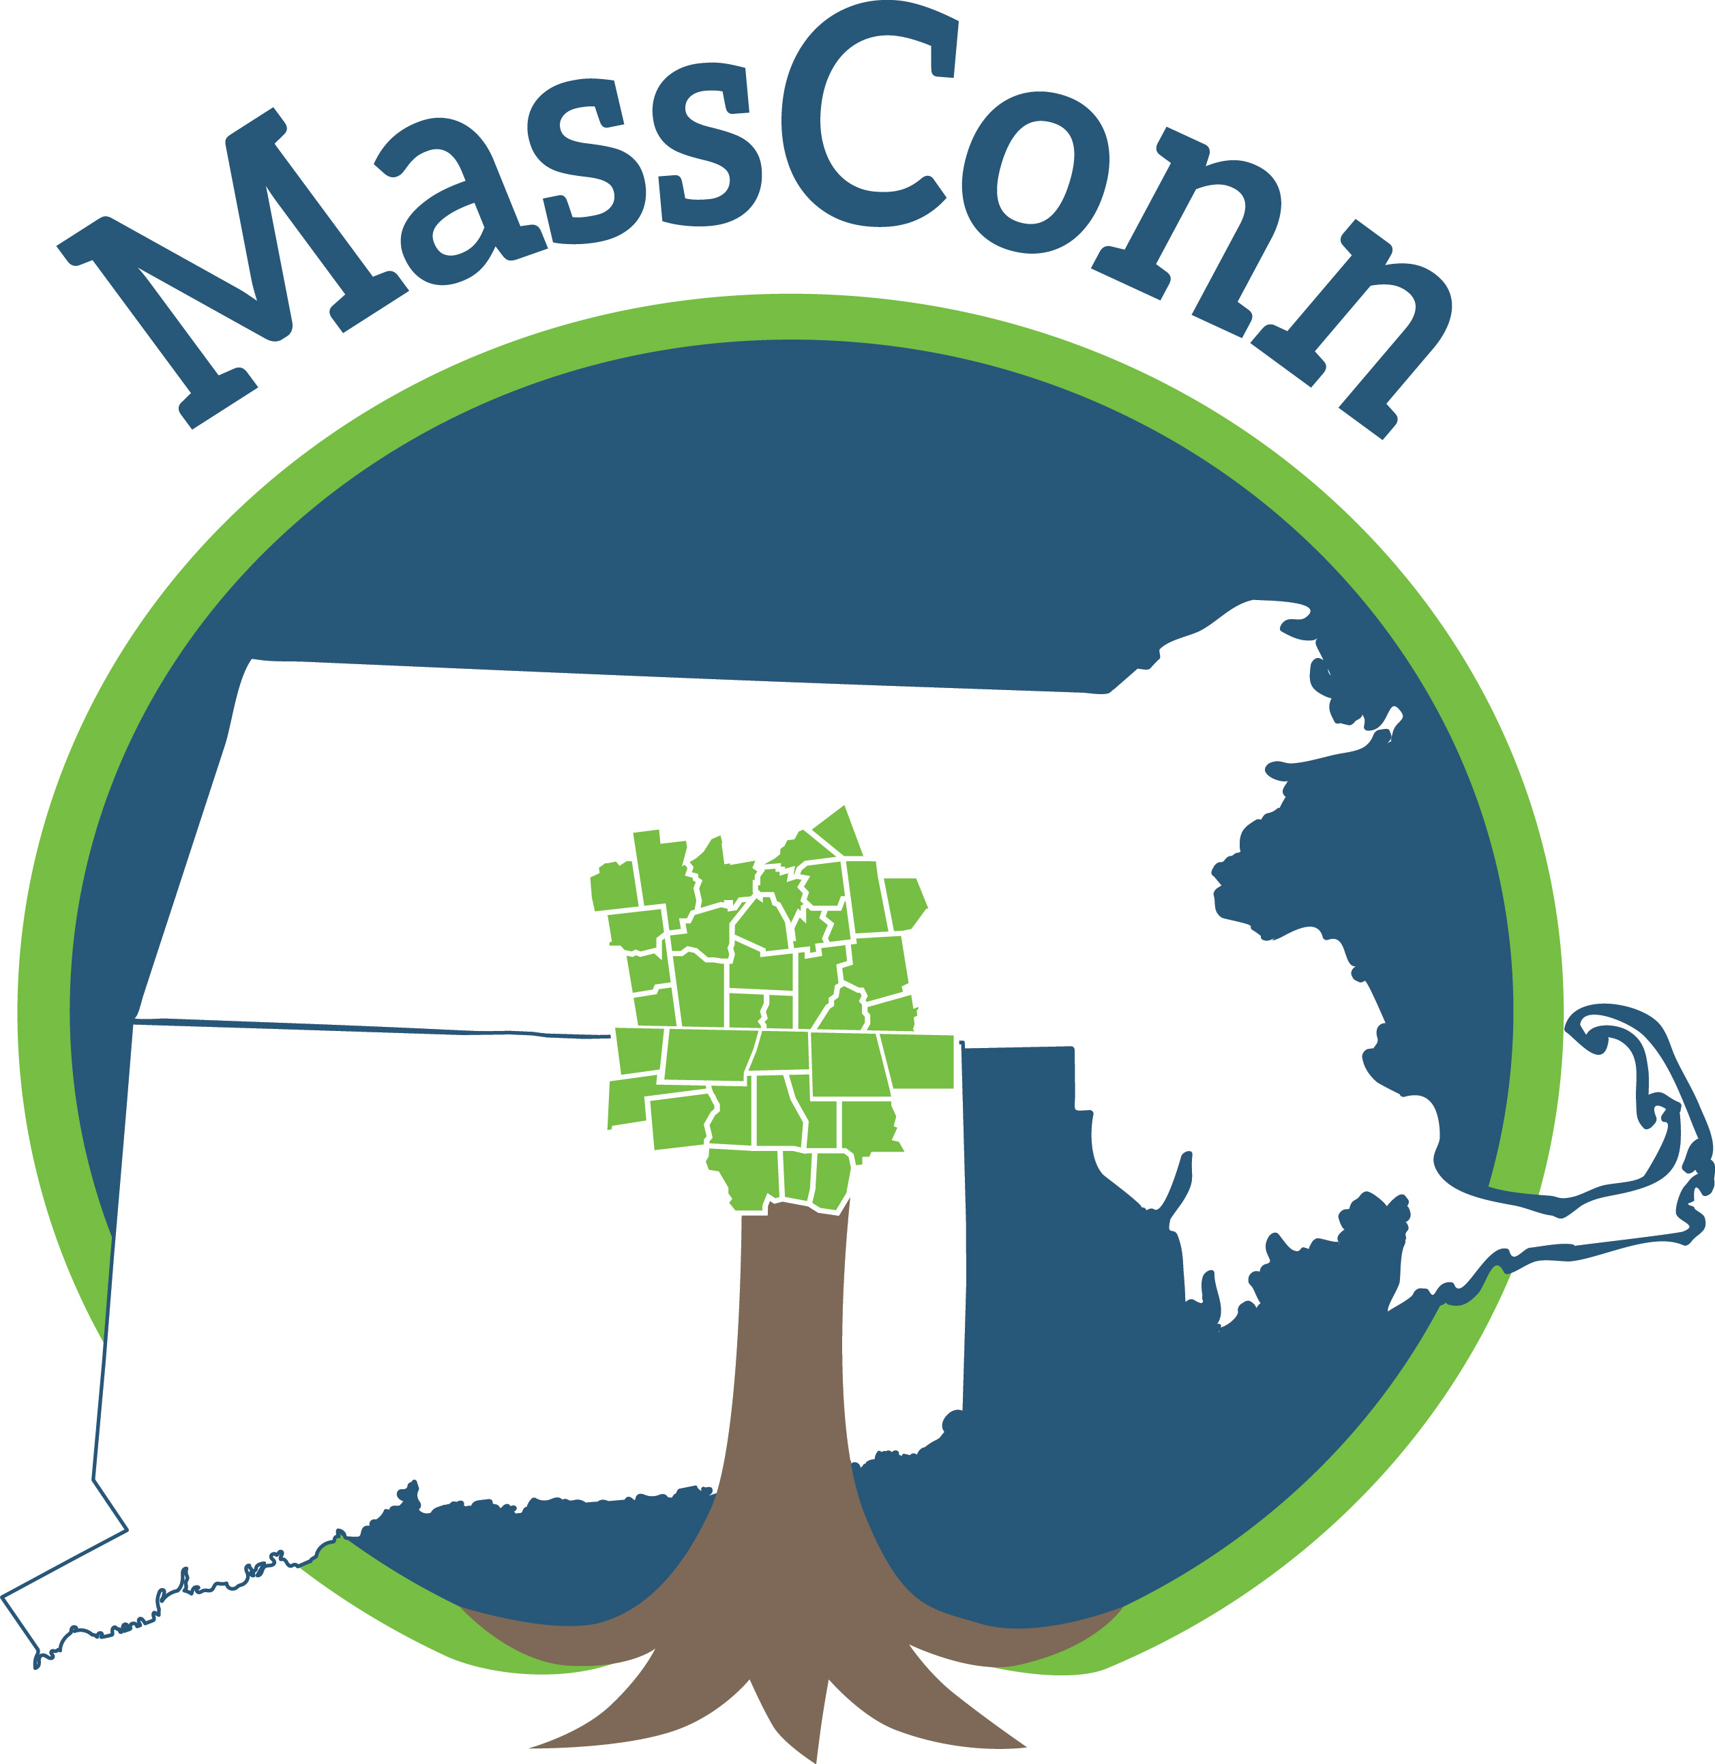

For Connecticut Projects For Massachusetts Projects For Rhode Island Projects
The Last Green Valley MassConn Sustainable Northern RI Conservation
Forest Partnership District
Bill Reid Kate Hauske Kate Sayles
Bill@tlgv.org Massconn@opacumlt.org ksayles.nricd@gmail.com
860-774-3300 413-687-9381 401-934-0840

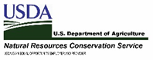

This project is funded in part by a Regional Conservation Partnership Program Grant #68-1106-17-058 from the Natural Resources Conservation Service, U.S. Department of Agriculture. NRCS/USDA and the lead project partners are equal opportunity providers, employers, and lenders.

Supporting Partners: MA Executive Office of Energy and Environmental Affairs, Providence Water, Yale School of Forestry & Environmental Studies, CT Department of Energy and Environmental Protection, Hull Forest Products, Thames River Basin Partnership, New England Forestry Foundation, Eastern CT Conservation District, Norcross Wildlife Foundation, RI Division of Forest Management, RI Woodland Partnership, Harvard Forest, Yale Sustaining Family Forests Institute, Audubon Connecticut, Mass Audubon, and Audubon RI.

Project Area - The Southern New England Heritage Forest Region

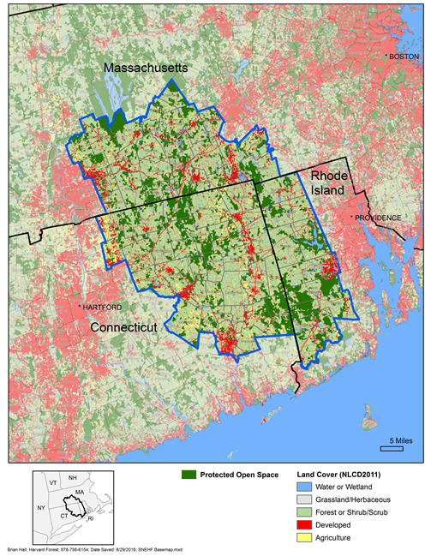

Connecticut Towns: Ashford, Brooklyn, Canterbury, Chaplin, Coventry, Eastford, Ellington, Franklin, Griswold, Hampton, Killingly, Lebanon, Lisbon, Mansfield, Norwich, Plainfield, Pomfret, Preston, Putnam, Scotland, Sprague, Stafford, Sterling, Somers, Thompson, Tolland, Union, Willington, Windham, Woodstock, Voluntown

Massachusetts Towns: Belchertown, Brimfield, Brookfield, Charlton, Douglas, Dudley, East Brookfield, Granby, Hampden, Holland, Leicester, Ludlow, Monson, New Braintree, North Brookfield, Oakham, Oxford, Palmer, Spencer, Southbridge, Sturbridge, Sutton, Wales, Ware, Warren, Webster, West Brookfield, Wilbraham

Rhode Island Towns: Burrillville, Coventry, Exeter, Foster, Gloucester, Hopkinton, Richmond, Scituate, West Greenwich

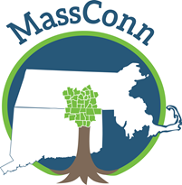
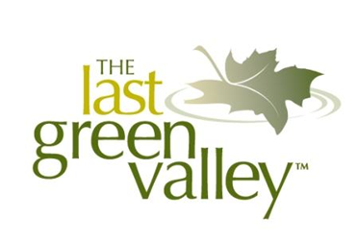

Dear Landowner:

Do you love your woods? Are you interested in birds? Do you want to learn more about how to make your woods healthy for the birds in your area? We can help!

The Last Green Valley (TLGV), the MassConn Sustainable Forest Partnership (MassConn) and the Northern Rhode Island Conservation District (NRICD) are pleased to offer a new funding opportunity for woodland landowners to obtain forest management plans with bird habitat assessments through the USDA – Natural Resources Conservation Service (NRCS) for properties located in the Southern New England Heritage Forest. *

Through this funding we will be providing cost-share assistance to cover much of the cost to hire a professional forester to create forest management plan for your woods.

Through this cost-share assistance program a professional forester will walk your property and coordinate with you, Mass Audubon, Mass DCR, and NRCS to produce a high-quality forest management plan with a bird habitat assessment for your woods. The plan will contain recommendations for management measures that align with your goals for the property. The plan will meet federal and state requirements and may be used to apply for the Massachusetts Chapter 61 tax program.

NRCS funds, provided through MassConn and The Last Green Valley, are available to pay for most of the forester’s costs and to completely fund the bird habitat assessment. As a landowner, you will be responsible for choosing a forester from an approved list and for paying a percentage of the total cost of the forest management plan. Rates are set by acreage.

This program is ideally suited for landowners who have never had a forest management plan and own more than 10 acres of woodlands. This program is also suited for landowners who have never had a Massachusetts DCR Bird Habitat Assessment. The MassConn Sustainable Forest Partnership staff are available to provide you with assistance and a site visit on your land to assess your property, to help you apply for the funding and guide you as you implement this program.

To get started, contact Kate Hauske with the MassConn Sustainable Forest Partnership, by email at Massconn@opacumlt.org or by phone at 413.687.9381. Kate can help you determine if this program is right for you and assist you in filing the correct paperwork. The application deadline is rolling, with applications received on or before the 15th of each month processed, until funding runs-out.

*Southern New England Heritage Forest Towns in Massachusetts: Belchertown, Brimfield, Brookfield, Charlton, Douglas, Dudley, East Brookfield, Granby, Hampden, Holland, Leicester, Ludlow, Monson, New Braintree, North Brookfield, Oakham, Oxford, Palmer, Spencer, Southbridge, Sturbridge, Sutton, Wales, Ware, Warren, Webster, West Brookfield, Wilbraham

Southern New England Heritage Forest (SNEHF)
Regional Conservation Partnership Program (RCPP)
Environmental Quality Incentives Program (EQIP) Application Form
Forest Management Plan with Bird Habitat Assessment
Cost-share Application - Massachusetts

1. Applicant and Parcel Information

Landowner Name(s)

Application Date
Landowner Address

Landowner Phone | Landowner Email
Parcel Location (If different from Landowner Address)

Assessor’s Map-Block-Lot Number | Number of Acres
FSA Farm & Tract Number
2. Are you applying to participate in a conservation program as an (check one of the following):
□ Individual
a) Please enter your legal name and tax identification number  Name: | Tax Number:
□ Entity (Corporation, Limited Partnership, Trust, Estate etc.)
a) Please enter entity legal name and tax identification number  Name: | Tax Number:
□ Joint Operation (General Partnership, Joint Venture)
a) Please enter joint operation legal name and tax identification number  Name: | Tax Number:
b) □ Yes □ No Do you have appropriate documents including proof to sign for the joint operation?
3. The land offered under this application is (check all that apply):
□ Private Land
□ Public Land (Federal, State or Local Government)
□ Tribal, Allotted, Ceded or Indian Land
4. You certify that Certification of control of the land offered under the application is evidenced by:
□ Deed or other evidence of land ownership
□ Written Lease Agreement
Years of control are ______ through ______
□ Other agreement or legal conveyance (describe):
Years of control are ______ through ______
5. Do you meet the criteria for any of the following categories? (mark all that apply)
□ Limited Resource Farmer or Rancher
□ Beginning Farmer or Rancher
□ Socially Disadvantaged Farmer or Rancher
□ Veteran Farmer or Rancher
□ Not Applicable

If you wish to apply in any of these categories, you must meet the self-certification requirements. Definitions are provided below. For more information please go to this website: https://lrftool.sc.egov.usda.gov/

Limited Resource Farmer or Rancher – The term “Limited Resource Farmer or Rancher” means a participant:
- With direct or indirect gross farm sales not more than the current indexed value in each of the previous two years, and
- Who has a total household income at or below the poverty level for a family of four, or less than 50 percent of the county median household income in each of the previous two years.
A legal entity or joint operation can be a Limited Resource Farmer or Rancher only if all individual members independently qualify. A Self-Determination Tool is available to the public and may be completed on-line or printed and completed hardcopy at: https://lrftool.sc.egov.usda.gov/

Beginning Farmer or Rancher – The term “Beginning Farmer or Rancher” means a participant who:
- Has not operated a farm or ranch, or who has operated a farm or ranch for not more than 10 consecutive years. This requirement applies to all members of a legal entity, and who
- Will materially and substantially participate in the operation of the farm and ranch.
In the case of a contract with an individual, individually or with the immediate family, material and substantial participation requires that the individual provide substantial day-to-day labor and management of the farm or ranch, consistent with the practices in the county or State where the farm is located.
In the case of a contract made with a legal entity, all members must materially and substantially participate in the operation of the farm or ranch. Material and substantial participation requires that the members provide some amount of the management, or labor and management necessary for day-to-day activities, such that if the members did not provide these inputs, operation of the farm or ranch would be seriously impaired.

Socially Disadvantaged Farmer or Rancher- The term “Socially Disadvantaged” means an individual or entity who is a member of a socially disadvantaged group. For an entity, at least 50 percent ownership in the far business must be held
by socially disadvantaged individuals. A socially disadvantaged group is a group whose members have been subject to racial or ethnic prejudice because of their identities as members of a group without regard to their individual qualities.

These groups consist of the following:
- American Indians or Alaskan Natives
- Asians
- Blacks or African Americans
- Native Hawaiians or other Pacific Islanders
- Hispanics
Note: Gender alone is not a covered group for the purposes of NRCS conservation programs.

Veteran Farmer or Rancher- The term “Veteran Farmer or Rancher” means a farmer or rancher who:
- Served in the active military, naval, or air service, and
- Who was discharged or released from the service under conditions other than dishonorable, and
- Who has not operated a farm or ranch; or has operated a farm or ranch for not more than 10 consecutive years.
A legal entity or joint operation can be a Veteran Farmer or Rancher only if all individual members independently qualify.
6. Does the land offered under this application have a current Management Plan?:
□Forest Management Plan written by a Certified Forester or Technical Service Provider?

Active since _____ Current through _____

Who wrote your plan?: _____________________________________

Is your plan filed with DCR?: _________ Is your plan filed with NRCS?:_________
□Forest Stewardship Plan written by a Certified Forester or Technical Service Provider

Active since _____ Current through _____

Who wrote your Plan?: _____________________________________
□ Bird Habitat Management Plan

Active since _____ Current through _____
□ Other (please explain)

Active since _____ Current through _____
□ Not Applicable
□ Are you currently approved for other Forest Management Plan cost-share?
Agency_____________

□ Have you ever been approved for and accepted any cost-share pertaining to you Plan?*
Agency_____________ Year____________
__
*Duplicate funds will not be awarded

7. Applicant Signature

I hereby certify that the information in this application is true and correct to the best of my knowledge.
_______________________________________ ________________
Applicant Signature Date

FY 2019 Southern New England Heritage Forest
Payment Schedules for Forest Management/Stewardship Plans with Bird Habitat Assessments

Massachusetts
Funds paid to forester for a Stewardship Plan w/Bird Habitat Assessment that complies with NRCS and DCR Standards:

Less Than or Equal to 20 acres $1,078 + $300 $1,378 21 to 50 acres $1,362 + $400 $1,762
51 to 100 acres $1,362 + $500 $1,862
101 to 250 acres $2,440 + $600 $3,040
251 to 500 acres $3,519 + $700 $4,219
501 to 1000 acres $4,086 + $800 $4,886
Greater Than 1000 acres $5,108 + $900 $6,008

Funds paid to forester for a Stand-alone Bird Habitat Assessment Addendum to existing Stewardship Plans in Massachusetts:

1 to 20 acres $ 600
21 to 50 acres $ 800
Greater Than 51 acres $1,000

Completed applications can be sent to:

Kate Hauske
MassConn Sustainable Forest Partnership
PO Box 233
Sturbridge, MA 01566

For more information contact:

Massachusetts Projects
MassConn Sustainable
Forest Partnership
Kate Hauske
MassConn@opacumlt.org
(413)687-9381

This project is funded in part by a Regional Conservation Partnership Program Grant #68-1106-17-058 from the Natural Resources Conservation Service, U.S. Department of Agriculture. NRCS/USDA and the lead project partners are equal opportunity providers, employers, and lenders.

