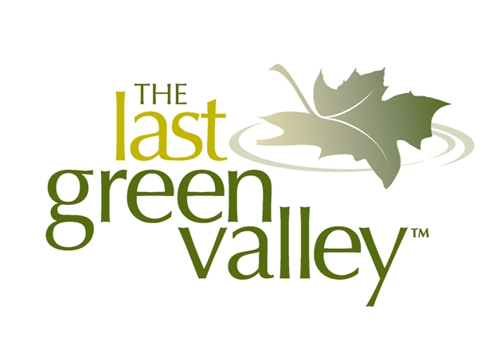

May 2020
Please check with each market before you visit – conditions
and operations are changing rapidly as farms adapt to current requirements.

FARMER’S MARKETS
(Information compiled from many sources including farm and market websites, social media and TLGV Explore Guide; CT Northeast Organic Farming Association & CT Dept of Agriculture website; Mass. Dept. of Agricultural Resources website; municipal “Grown In” brochures including Lebanon and Mansfield; and Field Guide to Connecticut Farm Supported Agriculture Shares from Connecticut Farm & Food Magazine.)

Ashford Farmers’ Market
25 Tremko Lane/Pompey Hollow Park just off of Route 44.
facebook.com/pages/Ashford-Farmers-Market/456062064471661
The Ashford Farmer’s market runs from April 25 – October every Sunday from 10 am -1pm rain or shine. Fresh produce, fruit, baked goods, fruit syrups, jams, jellies, maple syrup, and local honey. They also feature massage, herbal products and local crafts.

Brimfield Farmers’ Market/Hitchcock Academy – The Farmer’s Market
2 Brookfield Rd./North Main St.
The Farmers Market will now be open every Saturday 9 -2 to provide this important resource for our surrounding communities. At this time there are only fresh food and plant vendors. We ask that all vendors and customers wear a mask, maintain a social distance and try to have exact change to limit cash transactions. For a complete explanation of the safety protocols we have put in place please visit Hitchcock Academy.

Canterbury Farmers’ Market
1 Municipal Drive
Vendors offer locally grown fruits, vegetables, eggs, organic herbs, local honey and farm-crafted products such as soaps, cheese and breads. Every Tuesday from 4:30 – 6:30 pm June 2 – October.

Coventry Farmers Market at Hale Homestead
2299 South St.
facebook.com/coventryfarmersmarket and instagram: instagram.com/coventryfarmersmarket
Opening in June. The mission of the Coventry Farmers’ Market at Hale Homestead is to provide a dynamic and sustainable marketplace for the exchange of high quality, locally grown and crafted products and services directly to the consumer. The Market also serves to promote local economic development and community enrichment by cultivating a vibrant gathering place offering educational, artistic, and social activities.

Lebanon Farmers’ Market
579 Exeter Rd.
860-642-2006, lebanontownhall.org/department.htm?id=ept0pfzv
Lebanon Farmers’ Market has 15 vendors featuring a wide variety of agricultural-related products including vegetables, flowers, herbs, plants, honey, garlic, fiber, maple syrup, meat, cheese, bakery items, etc. Early June – Mid October, Saturdays 9 am – 12 noon. Green Certified FMNP Authorized

Northeast CT Farmers’ Market
860 564-1117
Brooklyn Commons Shopping Center, 564 Providence Rd., Weds. 4 – 6 pm
Killingly Public Library, 25 Westcott Rd., Sat. 9 am – 12 pm
Plainfield Early Childhood Center, 651 Norwich Rd., Tues. 4 – 6 pm
Putnam Riverview Marketplace, 18 Kennedy Dr., Mon. 3:30 – 6 pm
Since 1980, the Northeast CT Farmers Market Association has operated farmers markets in the “Quiet Corner” of CT. The main purpose of the markets is to provide a centralized location for consumers to purchase locally grown fresh fruit, vegetables and other farm products, create a vehicle for local farmers to sell their produce directly to the public enabling many of them to stay in business and enhance the local economy. Currently, the Association operates four markets each week in Killingly, Putnam, Plainfield and Brooklyn, during our growing/harvesting season – from May – Oct. Keep up to date online & on Facebook. CSA available May – Oct. for weekly pickup at the Putnam location from 4:30-6 pm.

Putnam Saturday Farmers’ Market
Putnam Riverview Marketplace, 18 Kennedy Dr.
860-963-6834, putnamfarmersmarket.org
Putnam Saturday Farmers’ Market is located in the Riverview Marketplace Pavilion located at 18 Kennedy Drive, Putnam, CT. The Putnam Saturday Farmers’ Market is very grateful to the farmers, vendors, guests and artisans who participate and to the hundreds of customers who’ve come to enjoy. The Market is brought to you by the Town of Putnam‘s office of Economic and Community Development. They accept SNAP/EBT cards and debit cards. They’re open Saturdays, early June through late October, from 10 am to 1 pm. Certified FMNP Authorized

Southbridge Farmers’ Market
Big Bunny Big Bunny Market, 942 Main St.
Contact: Pete Cournoyer, pete@bigbunnymarket.com, 508-765- 9824 ext.101
Saturday, 9:00 am - 2:00 pm, May 30 to October 17.
EBT-SNAP Accepted, HIP

STAR Cooperative Farmer’s Market (Sturbridge/FIskdale)
559 Main St.
774-241-0430, farmersmarketonline.com/fm/STARCooperativeFarmersMarket.html?fullweb=1Last Sundays, 10 am – 3 pm August – November. Operated by a natural foods buying club, this is a seasonal open air market featuring local produce, plants, herbs, artisan breads, bakery items, handmade dog treats, craft items and more.

Storrs Farmers’ Market (Mansfield)
Audrey Beck Municipal Bldg. parking lot, 42 N. Eagleville Rd.
facebook.com/pages/Storrs-Farmers-Market/57480811831
Fresh fruits, vegetables, dairy, maple products, honey. May – November; Saturdays, 3:00 – 6:00 pm rain or shine.

Sturbridge Farmers’ Market
Sturbridge Town Common, 278 Main St.
Contact: Caitlin Tomko, sturbridgefarmersmkt@gmail.com, 508-347-2500 ext. 1411
Sunday, 9:00 am - 1:00 pm, June 7 to October 11, HIP

Voluntown Farmers’ Market
Voluntown Elementary School, 195 Main St.
voluntown.biz/voluntown-farmers-market-2
The Voluntown Farmers’ Market is here to serve the people of Voluntown by providing locally grown, fresh, high quality produce and products, and to provide local farmers, producers and artisans with an economic outlet within Voluntown. The Voluntown Farmers’ Market further strives to bring more foot traffic to Main St., providing local merchants with the opportunity to strengthen their businesses and keep the town center economically viable. July 12- Oct. 11 Every Sunday 10 am -1 pm.

Willimantic Farmers’ Market
Jillson Square, Jackson St.
farmfresh.org/food/farmersmarkets_details.php?market=334
The Willimantic Farmers’ Market is open Saturdays 8 am – 12 noon, May through October at the corner of Jackson and Union Sts., under the pavilion near the Frog Bridge. Vegetables, fruit, dairy, herbs, honey, maple syrup. Certified FMNP Authorized.

