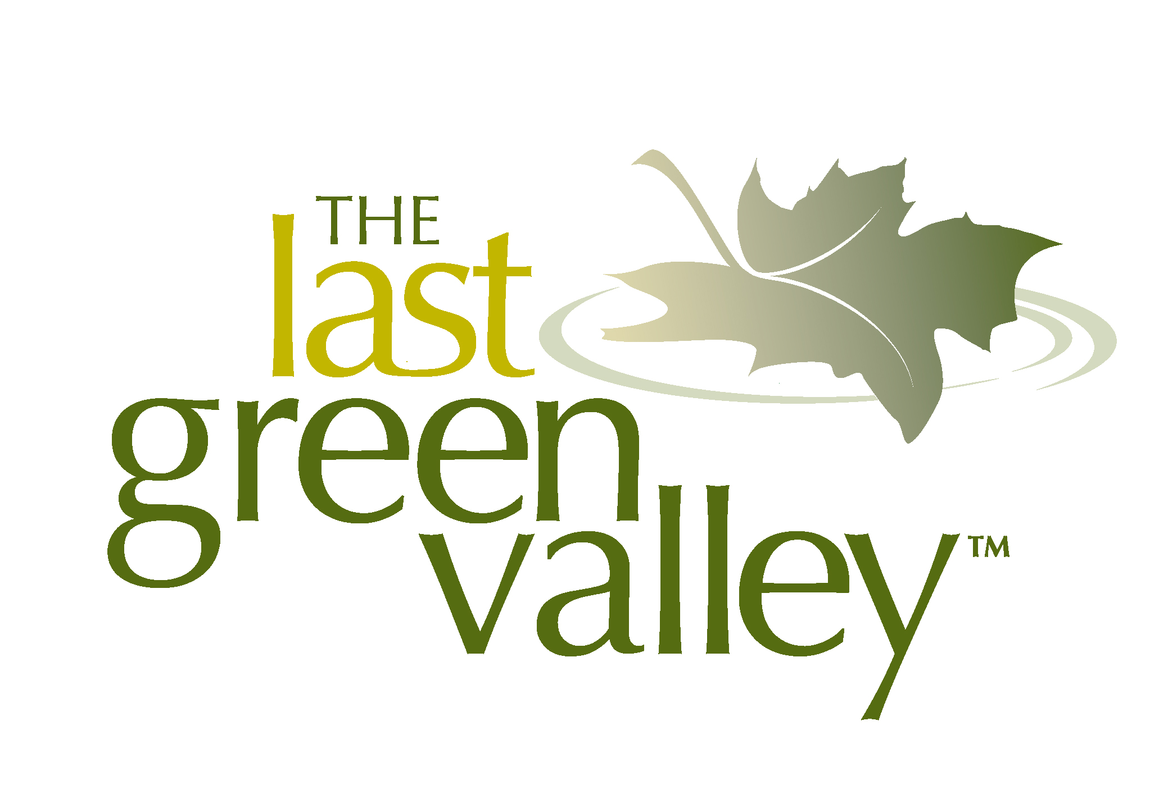
2021Trash Tracker

Thank you for participating in today’s cleanup! Your commitment is a great step towards ensuring we can all enjoy The Last Green Valley year-round. The data you collect during the cleanup is invaluable in documenting and educating the public, businesses and government officials about the scale and serious consequences of trash in our public places. Thank you. We could not do it without your help!

1. Cleanup Site Information

Location (site, town): _________________________________________________________ Date __________________

Distance or area cleaned________________________________________ Estimated time spent on cleanup __________

Name _______________________________Email __________________________ Phone _______________________

Number of trash bags filled _________Total estimated weight of bags (ave. 15 lbs./full bag) ________________lbs.

Total estimated weight of bulky (non-bagged) items __________Total estimated weight of all items ____________

2. Items Collected - Please estimate the number of items you picked up.

Cigarettes/Cigarette Filters_____________________ Cigar Tips_______________________________
Cigarette Lighters__________________________ Tobacco Packaging/Wrappers_______________________
Paper Bags ______________________________ Plastic Bags _____________________________________
Balloons _________________________________ Plastic Beverage Bottles (2 liters or less) _______________
Glass Beverage Bottles _____________________ Beverage Cans___________________________________
Caps, Lids _______________________________ Clothing, Shoes___________________________________
Cups, Plates, Forks, Knives, Spoons___________ Food Wrappers/Containers__________________________
Pull Tabs_________________________________ 6-Pack Holders___________________________________
Straws, Stirrers____________________________ Toys____________________________________________
Nip Bottles _____________________________ Lottery tickets ___________________________________
Appliances (refrigerators, washers, etc.)________ Batteries________________________________________ Building Materials__________________________ Cars/Car Parts____________________________________
55-Gal. Drums_____________________________ Tires____________________________________________
Shopping Carts ____________________________ Light Bulbs/Tubes_________________________________
Oil/Lube Bottles ____________________________ Plastic Sheeting/Tarps_____________________________
Rope_____________________________________ Bleach/Cleaner Bottles_____________________________
Furniture ________________________________ Propane Tank ___________________________________
Condoms_________________________________ Diapers_________________________________________
Syringes_________________________________ Feminine Hygiene Products_________________________
Bait Containers/Packaging___________________ Buoys/Floats _____________________________________
Fish/Animal Traps_________________________ Fishing Line/Nets__________________________________
Fishing Lures/Light Sticks____________________ Shotgun Shells/Wadding____________________________

Debris Items of Local Concern - Identify and count up to 3 other items that concern you.
______________________________________________________________________________________________
______________________________________________________________________________________________
______________________________________________________________________________________________

What was the most unusual item(s) you collected? ___________________________________________________

The program is funded, in part, thanks to the support of bankHometown.

The Last Green Valley National Heritage Corridor is the last stretch of dark night sky in the coastal sprawl between Boston and Washington, D.C. The Last Green Valley, Inc. is a member-supported, non-profit organization working for you in the National Heritage Corridor.Together we can care for, enjoy and pass on The Last Green Valley!

