Southern New England Heritage Forest (SNEHF)
Regional Conservation Partnership Program (RCPP)
Environmental Quality Incentives Program (EQIP) Application

Funding Announcement – Monday, September 20th, 2021

Lead Partners:
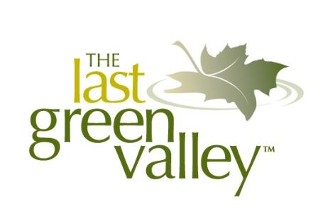
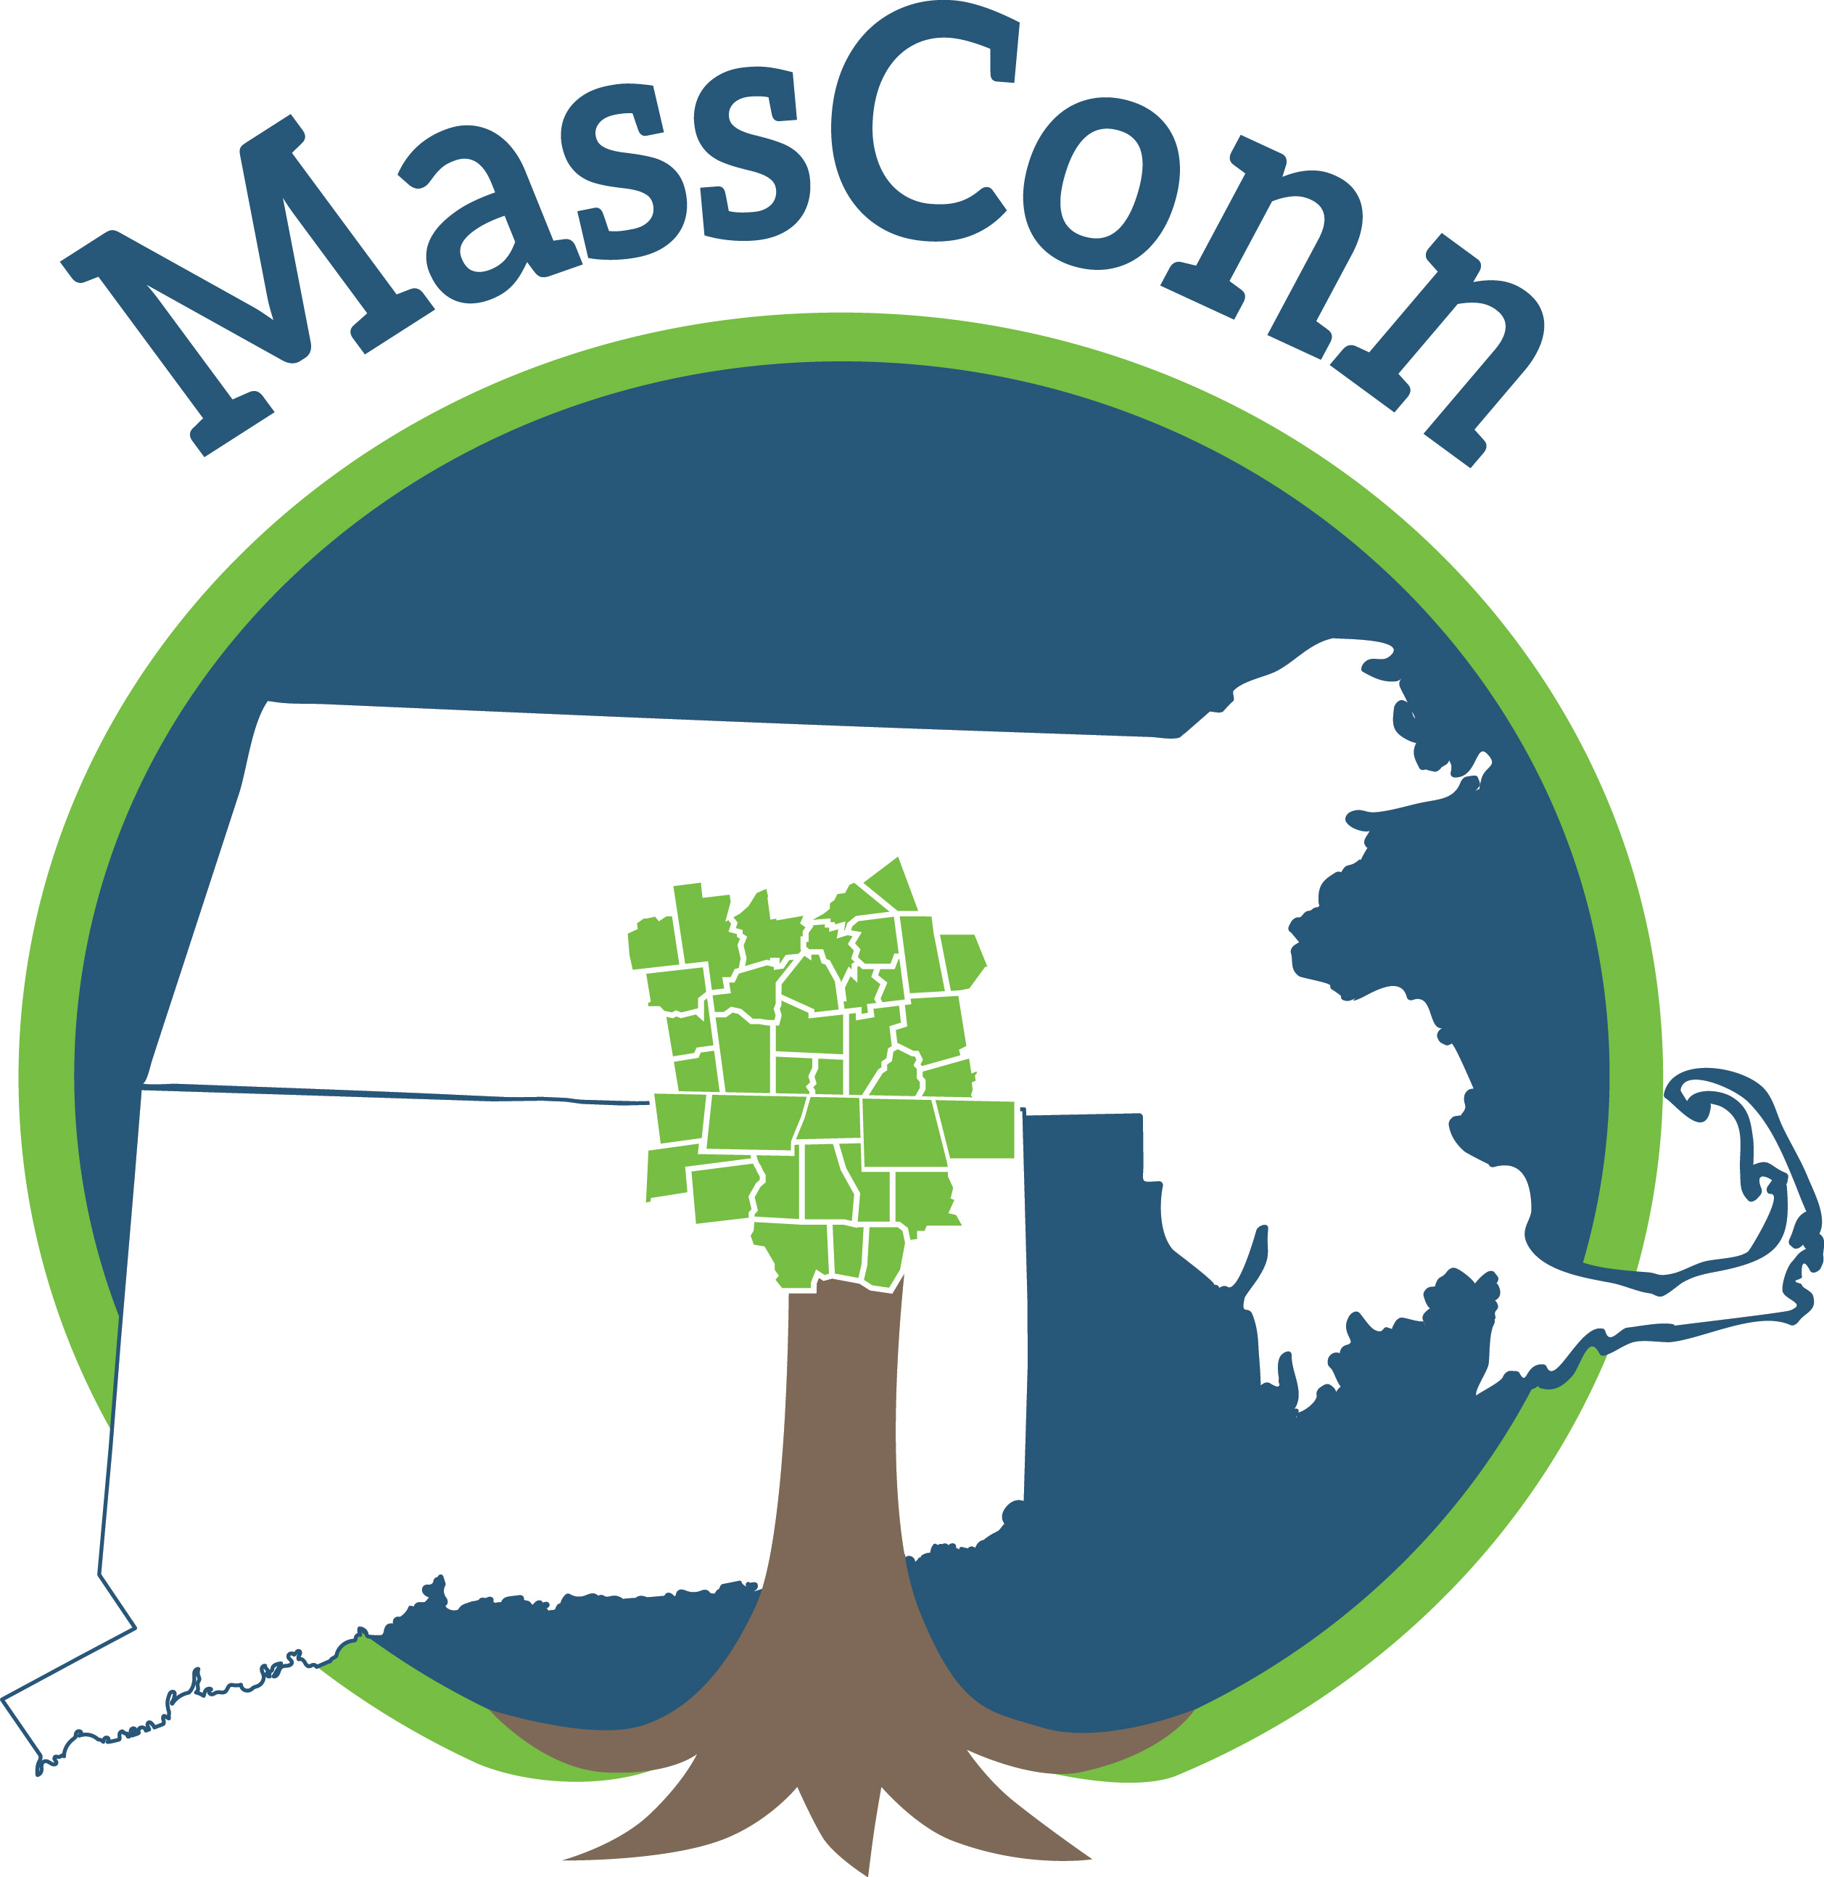

For Connecticut Projects For Massachusetts Projects For Rhode Island Projects
The Last Green Valley MassConn Sustainable Northern RI Conservation
Bill Reid Forest Partnership District
Bill@tlgv.org Christopher Riely, CF Marina Capraro
860-774-3300 christopher@sweetbirchconsulting.com mcapraro.nricd@gmail.com
401-225-6135 401-934-0840

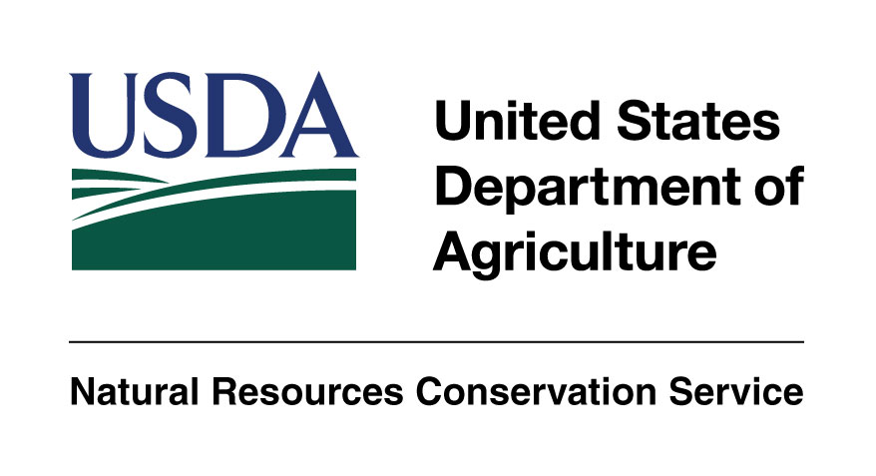

This project is funded in part by a Regional Conservation Partnership Program Grant #68-1106-17-058 from the Natural Resources Conservation Service, U.S. Department of Agriculture. NRCS/USDA and the lead project partners are equal opportunity providers, employers, and lenders.

Supporting Partners: MA Executive Office of Energy and Environmental Affairs, Providence Water, Yale School of Forestry & Environmental Studies, CT Department of Energy and Environmental Protection, Hull Forest Products, Thames River Basin Partnership, New England Forestry Foundation, Eastern CT Conservation District, Norcross Wildlife Foundation, RI Division of Forest Management, RI Woodland Partnership, Harvard Forest, Yale Sustaining Family Forests Institute, Audubon Connecticut, Mass Audubon, and Audubon RI.

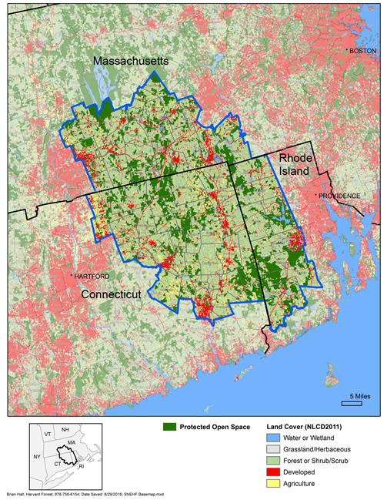

Connecticut Towns: Ashford, Brooklyn, Canterbury, Chaplin, Coventry, Eastford, Ellington, Franklin, Griswold, Hampton, Killingly, Lebanon, Lisbon, Mansfield, Norwich, Plainfield, Pomfret, Preston, Putnam, Scotland, Sprague, Stafford, Sterling, Somers, Thompson, Tolland, Union, Willington, Windham, Woodstock, Voluntown

Massachusetts Towns: Belchertown, Brimfield, Brookfield, Charlton, Douglas, Dudley, East Brookfield, Granby, Hampden, Holland, Leicester, Ludlow, Monson, New Braintree, North Brookfield, Oakham, Oxford, Palmer, Spencer, Southbridge, Sturbridge, Sutton, Wales, Ware, Warren, Webster, West Brookfield, Wilbraham

Rhode Island Towns: Burrillville, Coventry, Exeter, Foster, Glocester, Hopkinton, Richmond, Scituate, West Greenwich

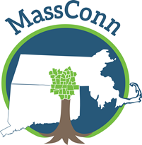
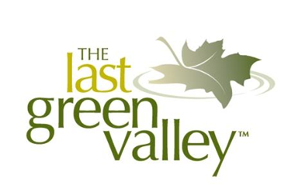

Dear Landowner:

Are your woods healthy? Can they bounce back from storms, pests or disease? Do they support diverse wildlife populations? Have you thought about harvesting timber for income?

If you are interested in learning more about your woods, we can help!

The Last Green Valley (TLGV), the MassConn Sustainable Forest Partnership (MassConn) and the Northern Rhode Island Conservation District (NRICD) are pleased to offer a new opportunity for woodland landowners to obtain forest management plans with bird habitat assessments.

A professional forester will walk your property and coordinate with the Audubon society in your state to produce a high-quality forest management plan with a bird habitat assessment of your woods. The plan will contain recommendations for management measures that align with your goals for the property. The plans will meet federal and state requirements and may be used to apply for property tax reductions at the local level (where applicable).

Grant funds are available to pay for most of the forester’s costs and to completely fund the bird habitat assessments. As a landowner, you will be responsible for choosing a forester from an approved list and for paying a percentage of the total cost of the forest management plan.

This program is ideally suited for landowners who have never had a forest management plan and own more than 10 acres of woodlands.

Program requirements vary by state, so to get started, contact the lead partner for your state who can help you file the correct paperwork. The application deadline is Friday, December 17th, 2021, but we recommend you begin the process as soon as possible to ensure your application is complete before the deadline.

**As a landowner in the Southern New England Heritage Forest (SNEHF), your woods are part of a 1.49 million-acre unfragmented forest corridor stretching along the Connecticut and Rhode Island border to the Quabbin Reservoir in Massachusetts. Bounded by more heavily urbanized areas, with more than one million nearby residents, the SNEHF has an astonishing 76% forest cover and offers one of the last viable wildlife corridors from southern to northern New England. The SNEHF is a green oasis and the last undeveloped region in the coastal sprawl from Boston to Washington, D.C. Because the SNEHF is so significant, a conservation partnership was formed to bring additional funding to the region through the USDA Natural Resources Conservation Service, Regional Conservation Partnership Program.

Southern New England Heritage Forest - Regional Conservation Partnership Program
Environmental Quality Incentives Program (EQIP) Application Form

1. Applicant and Parcel Information
Applicant Name(s) | Application Date
Applicant Address

Applicant Phone | Applicant Email
Landowner Name(s) if Different from Applicant

Landowner Contact Information if Different from Applicant
Parcel Location (If different from Applicant Address)

Assessor’s Map-Block-Lot Number | Number of Acres
FSA Farm & Tract Number

2. Are you applying to participate in a conservation program as an (check one of the following):
□ Individual – Please enter your legal name and tax identification number.
Name: | Tax Number:
□ Entity (Corporation, Limited Partnership, Trust, Estate etc.) – Please enter entity legal name and tax identification number.
Name: | Tax Number:
□ Joint Operation (General Partnership, Joint Venture) – Please enter joint operation legal name and tax identification number.
Name: | Tax Number:
□ Yes □ No Do you have appropriate documents including proof to sign for the joint operation?
3. The land offered under this application is (check all that apply):
□ Private Land
□ Public Land (Federal, State or Local Government)
□ Tribal, Allotted, Ceded or Indian Land
4. You certify that Certification of control of the land offered under the application is evidenced by:
□ Deed or other evidence of land ownership
□ Written Lease Agreement
Years of control are ______ through ______
□ Other agreement or legal conveyance (describe):
Years of control are ______ through ______
5. Do you meet the criteria for any of the following categories? (mark all that apply)
□ Limited Resource Farmer or Rancher
□ Beginning Farmer or Rancher
□ Socially Disadvantaged Farmer or Rancher
□ Veteran Farmer or Rancher
□ Not Applicable

If you wish to apply in any of these categories, you must meet the self-certification requirements. Definitions are provided below. For more information please go to this website: https://lrftool.sc.egov.usda.gov/

Limited Resource Farmer or Rancher – The term “Limited Resource Farmer or Rancher” means a participant:
- With direct or indirect gross farm sales not more than the current indexed value in each of the previous two years, and
- Who has a total household income at or below the poverty level for a family of four, or less than 50 percent of the county median household income in each of the previous two years.
A legal entity or joint operation can be a Limited Resource Farmer or Rancher only if all individual members independently qualify. A Self-Determination Tool is available to the public and may be completed on-line or printed and completed hardcopy at: https://lrftool.sc.egov.usda.gov/

Beginning Farmer or Rancher – The term “Beginning Farmer or Rancher” means a participant who:
- Has not operated a farm or ranch, or who has operated a farm or ranch for not more than 10 consecutive years. This requirement applies to all members of a legal entity, and who
- Will materially and substantially participate in the operation of the farm and ranch.
In the case of a contract with an individual, individually or with the immediate family, material and substantial participation requires that the individual provide substantial day-to-day labor and management of the farm or ranch, consistent with the practices in the county or State where the farm is located.
In the case of a contract made with a legal entity, all members must materially and substantially participate in the operation of the farm or ranch. Material and substantial participation requires that the members provide some amount of the management, or labor and management necessary for day-to-day activities, such that if the members did not provide these inputs, operation of the farm or ranch would be seriously impaired.

Socially Disadvantaged Farmer or Rancher- The term “Socially Disadvantaged” means an individual or entity who is a member of a socially disadvantaged group. For an entity, at least 50 percent ownership in the far business must be held by socially disadvantaged individuals. A socially disadvantaged group is a group whose members have been subject to racial or ethnic prejudice because of their identities as members of a group without regard to their individual qualities.

These groups consist of the following:
- American Indians or Alaskan Natives
- Asians
- Blacks or African Americans
- Native Hawaiians or other Pacific Islanders
- Hispanics
Note: Gender alone is not a covered group for the purposes of NRCS conservation programs.

Veteran Farmer or Rancher- The term “Veteran Farmer or Rancher” means a farmer or rancher who:
- Served in the active military, naval, or air service, and
- Who was discharged or released from the service under conditions other than dishonorable, and
- Who has not operated a farm or ranch; or has operated a farm or ranch for not more than 10 consecutive years.
A legal entity or joint operation can be a Veteran Farmer or Rancher only if all individual members independently qualify.
6. Does the land offered under this application have a current Management Plan?:
□Forest Management Plan written by a Certified Forester or Technical Service Provider
Active since _____ Current through _____
Who wrote your plan?: _____________________________________
□ Bird Habitat Management Plan
Active since _____ Current through _____
□ Other (please explain)

Active since _____ Current through _____
□ Not Applicable
7. Applicant Signature
I hereby certify that the information in this application is true and correct to the best of my knowledge.

_______________________________________ ________________
Applicant Signature Date

