May 25, 2023 TLGV Annual Meeting

3:30 pm - Pre-Meeting Activity - Walk, Talk and Tour of the Randall/Higginbotham Burial Ground at Wyndham Land Trust’s Nightingale Forest property.

Please register for this event by May 15 using the form on the reverse side or by visiting our website. Exact location and parking directions will be provided upon registration. We will walk approximately ½ mile to and from the burial ground on an old dirt road with some elevation changes. If you would like to attend but are concerned about the walk, please contact Kyle at kyle@tlgv.org or 860 774-3300 as we may be able to arrange alternate transportation.

Join local historian Donna Dufresne and Janet Booth from the Wyndham Land Trust for a walk, talk and tour of a family burial ground now owned by the land trust. Donna will talk about her ongoing research into the lives of the families who lived in the Mashamoquet uplands in the 18th and 19th centuries.

According to stories passed down through the descendants of the enslaved Randall family, some of their ancestors are buried in the back of the burial ground in roughly marked graves. Ground Penetrating Radar (GPR) readings conducted by the Office of State Archaeology in May 2021 show the possibility of 6 or 7 graves marked with small, almost unnoticeable fieldstones as markers. Although there is no documentation for the specific burials, Donna has traced enslaved Randalls from Reuben Randall, born in 1777 in Pomfret, to descendants who still live in the region.

Many family burial grounds in New England have been long abandoned and forgotten, but the Randall/ Higginbotham Burial Ground in Pomfret was looked after for more than 60 years by owners Mr. and Mrs. Harry Townshend, who donated the property to the Wyndham Land Trust in 2021 to be protected in perpetuity. The land became part of a group of parcels stewarded by the Trust called Nightingale Forest.

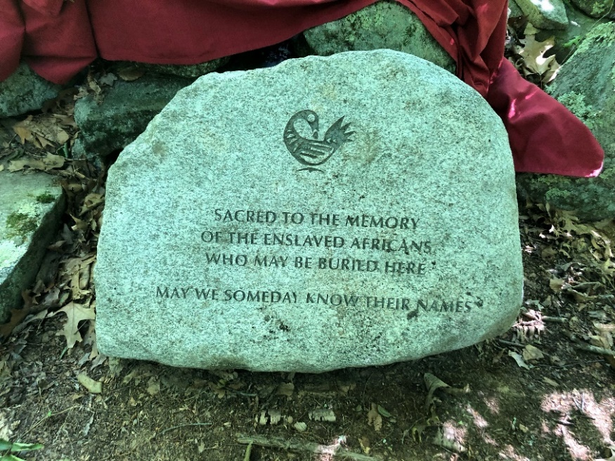
Wyndham Land Trust has successfully raised funds and installed a memorial stone for the unnamed, enslaved Africans who are presumed to be buried on the property. The memorial stone project seeks to foster awareness of those who were excluded from the written record, but whose lives and work contributed to the prosperity of a new nation and to the foundations that created the wealth of today. The project was supported in part by The Last Green Valley, the Connecticut Land Conservation Council and the Community Foundation of Eastern Connecticut.

