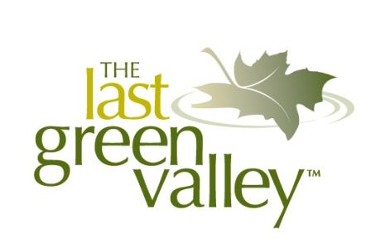2024 Photo Contest
for 2025 TLGV Calendar

Submission Form

Name _________________________________________________________

Address ____________________________________________________

Town_________________________________ State _ _ Zip __ __

Phone _____________________________________________________

Email _______________________________________

Website ______________________________________________________________________

Photo Title ____________________________________________

Location photo was taken _____________________________________________________

Additional description _____________________________________________________________________________
_____________________________________________________________________________
_____________________________________________________________________________
_____________________________________________________________________________

* Photos must be in color digital format, sized to 10” wide x 8” tall (landscape orientation), and at least 300 dpi

** We encourage submissions featuring people enjoying The Last Green Valley National Heritage Corridor but we must have written permission from any recognizable person in the photo before we can publish. If your photo is chosen as one of the 12 winners and contains recognizable people (particularly minors), we will contact you to obtain a release form from each person or their parents/guardians. Failure to obtain the signed release forms before our print deadline will be cause for us to choose another photo for publication.

By submitting this form with the attached photograph, I certify that I own the copyright to this work and that I knowingly transfer that copyright to The Last Green Valley, Inc. for its use. The Last Green Valley, Inc. will credit me whenever the photograph is used.

